

*Journal of Geophysical Research: Solid Earth*

Supporting Information for

**Impact of Crustal Rheology on Temperature-dependent Viscoelastic Models of Volcano Deformation: Application to Taal Volcano, Philippines**

A. M. Morales Rivera1,2, F. Amelung1, F. Albino1,3, and P. M. Gregg4

1Rosenstiel School of Marine and Atmospheric Science, University of Miami, Miami, FL, USA.

2Now at Chesapeake Energy Corporation, Oklahoma City, OK, USA.

3Now at School of Earth Sciences, University of Bristol, Bristol, UK.

4Department of Geology, University of Illinois at Urbana-Champaign, Champaign, IL, USA

**Contents of this file**

Text S1 to S3

Figures S1 to S13

Tables S1 to S18

**Additional Supporting Information (Files uploaded separately)**

Caption for Data Set S1

Text S1. InSAR data and processing

We use the Modular SAR Processor software (Werner et al., 2000) to focus the raw SAR images (Table S1) and a modified version of the ROI_PAC SAR Software (Rosen et al., 2004) to generate multilooked interferograms (4 looks), which are co-registered to a master image (master date: 08/28/2009). We remove topographic contributions using a 90 m resolution digital elevation model (DEM) obtained by the NASA Shuttle Radar Topography Mission (SRTM), which was resampled to 30 m. We applied a power spectrum filtering method (Goldstein & Werner, 1998) with a 0.125 coefficient to the interferograms, which were then unwrapped using the Statistical-cost Network-flow Algorithm for Phase Unwrapping (SNAPHU) (Chen & Zebker, 2001).

We select interferograms using a delaunay triangulation for pairs with perpendicular baselines smaller than 1300 m and temporal baselines smaller than 548 days to minimize decorrelation and create an interconnected network of 58 interferograms (Figure S1, Tables S2 and S3). We modified the network to eliminate interferograms severely affected by ionospheric phase delays (interferograms associated to date 10/16/2010) and interferograms with coherence loss of ≥0.5 over Taal volcano island (Table S2). We invert the interferogram network for the phase history using the Small Baseline (SB) method (Berardino et al., 2002). Incoherent pixels are masked out using a temporal coherence threshold of 0.7 to reduce bias from phase unwrapping (Pepe & Lanari, 2006).

Text S2. InSAR quality assessment

***Phase unwrapping of the island.*** We assessed the presence of unwrapping errors by evaluating the temporal coherence over our area of interest. Unwrapping errors typically appear as abrupt changes in the temporal coherence and are commonly observed over islands separated from the mainland, which is the case over Taal volcano island (Figure S2a). We correct for unwrapping errors over Taal volcano island at each epoch following a bridging or bonding point approach, which uses a coherent reference point in the mainland and in proximity to the area with unwrapping error to provide a phase continuity constrain (Figures S2b and S2c). The corrected interferograms were then inverted to obtain the time series (Figure S3), with improved temporal coherence over Taal volcano island after unwrapping error correction (Figure S2c).

***Reference date.*** The InSAR displacement time series shows relative measurements, and we use the following approach to choose the optimal reference date. We first calculated the sum of the time series displacements per epoch, referencing each epoch as the master date. We proceeded by applying a feature scaling method to the sum of the displacements per epoch results to rescale the values from 0 to 1 (Figure S4), where values closer to 0 can be associated to higher atmospheric noise. We chose the epoch with the averaged value closest to 1 (epoch 07/13/2009) as the reference date (Figure S5).

***Phase corrections.*** The time series where finally corrected for residual long-wavelength phase ramps (Figure S6) by estimating the planar surface that best fits the interferometric phase at each epoch. We evaluated if correction was needed for stratified tropospheric delays using the phase-elevation correlation method but found it was negligible because the phase-elevation correlation was always less than 25% at each epoch. Finally, the displacement time series and averaged velocities are georeferenced. The time series provides line-of-sight (LOS) measurements relative to a single reference pixel located away from the volcano to exclude deformation (See Figure 1a in main manuscript for reference point location).

Text S3. Analytical and numerical solution comparisons

Predicted displacements from our viscoelastic numerical models at time zero equals the instantaneous or elastic deformation, and can be used to compare and verify the results with the elastic analytical solution for a pressurized spherical source (McTigue, 1987; Mogi, 1958). We built a viscoelastic model in Comsol with the same amount of domains as Figure 2 of the manuscript, using the same radius, depth, and overpressure of the best-fitting viscoelastic solution, but in a medium with homogeneous elastic properties (Table S5). We show in Figure S11 that there is good agreement between the analytical and numerical solutions, and the similarity between the numerical solution for a homogeneous and heterogeneous medium, validating the numerical setup of the viscoelastic models. Elastic homogeneity provided similar results to elastic heterogeneity within the medium because the resolution of the seismic data for the uppermost crust is of 2 km (You et al., 2013), which would generate 3 heterogeneous domains above the source compared to 1 for the homogeneous case.

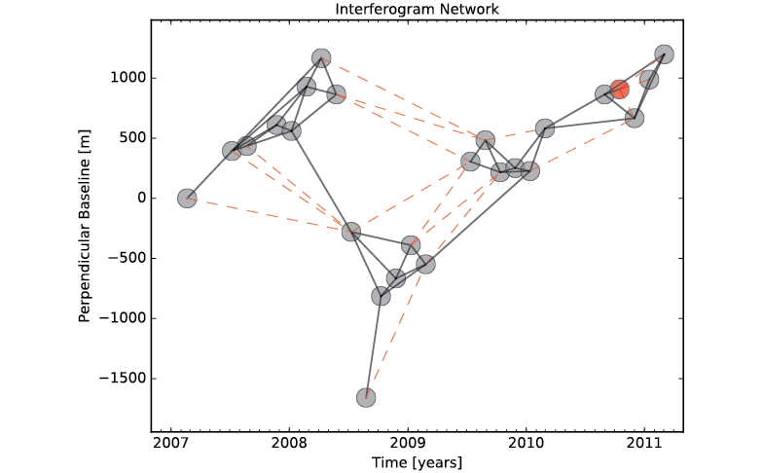

Figure S1. Delaunay network of interferometric pairs used for SBAS time series generation. Red circle: epoch removed during post-processing due to presence of ionospheric delay. Red dashed lines: interferograms removed during post-processing due to low spatial coherence over Taal Volcano Island (See Text S1).

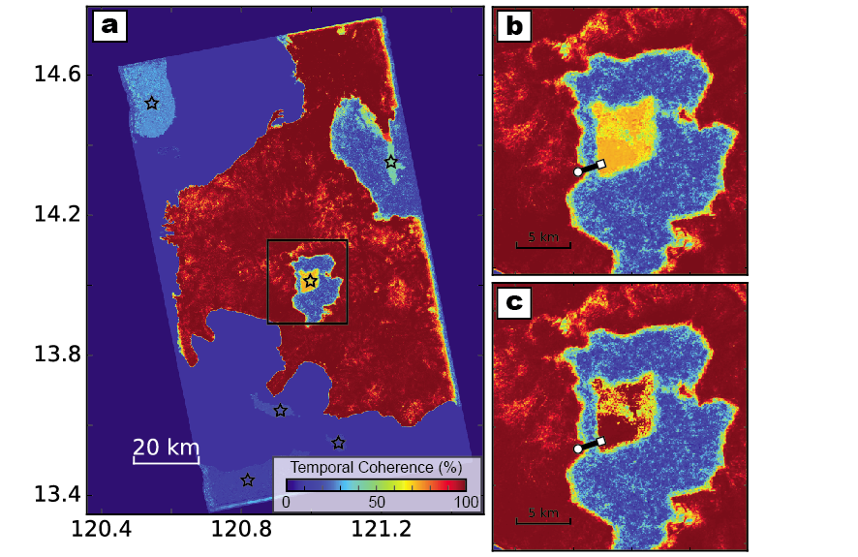

Figure S2. Temporal coherence map for Track 449 (a) with multiple unwrapping errors marked by black stars. The black square delineates the area covered in (b) and (c), respectively showing the temporal coherence prior to and after unwrapping error correction over Taal Volcano Island. White circle connected to white square is the reference and bonding point respectively, used for the unwrapping error correction.

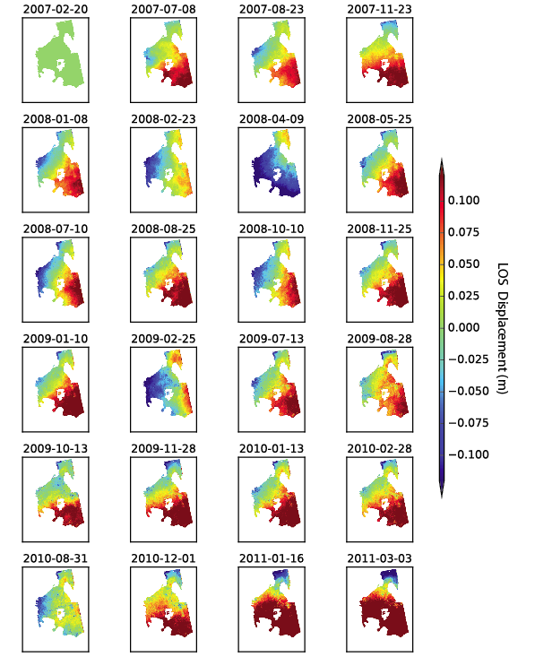

Figure S3. Displacement time series obtained after the interferogram network inversion, with first date as reference epoch.

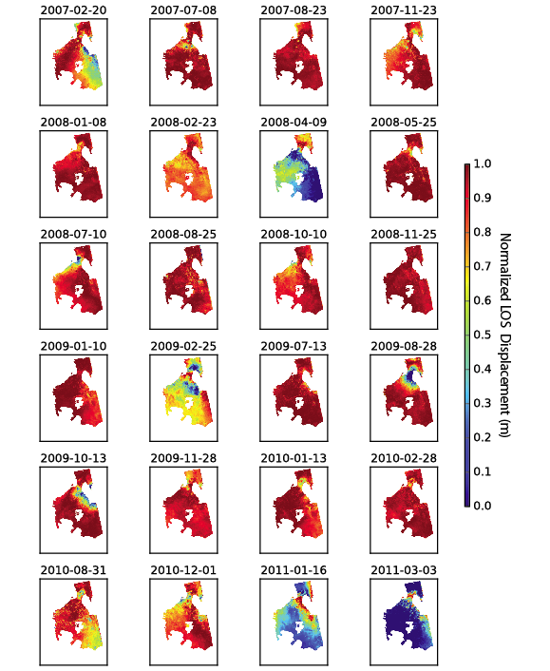

Figure S4. Normalized temporal displacement per epoch.

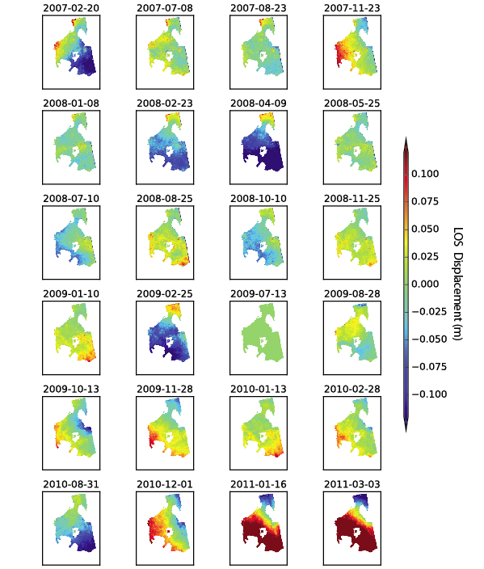

Figure S5. Same as Figure S3 but with 13 July 2009 as the reference date.

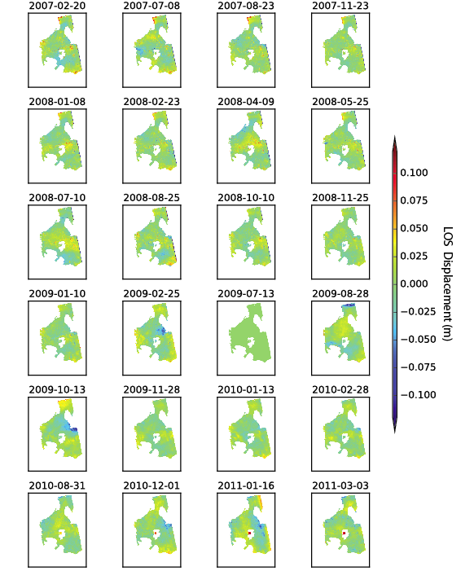

Figure S6. Same as Figure S5 but with plane surface removed.

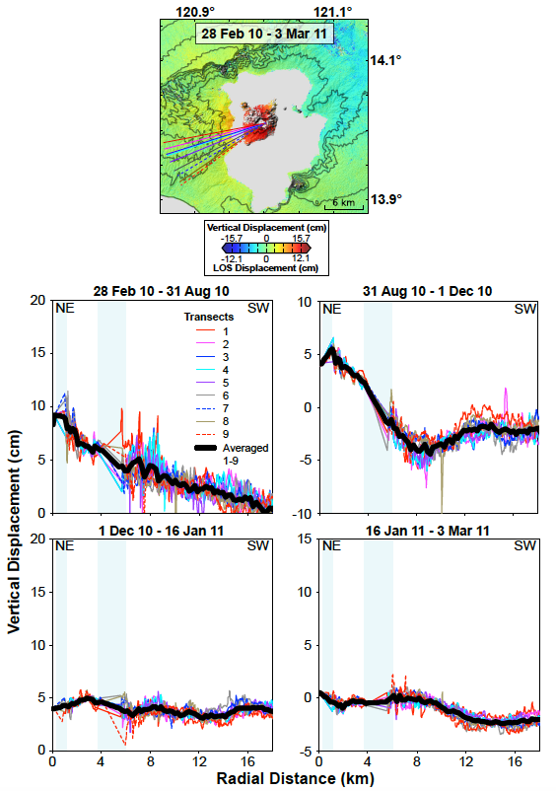

Figure S7. (Above) Approximated vertical displacement over Taal volcano and surroundings between February 2010 and March 2011 showing the location of profiles on the bottom figures. (Below) Vertical (Transects 1-9) and averaged (from Transects 1-9; solid black lines) displacement profiles for the InSAR periods under analysis. The origin (NE) is the location of the best-fitting analytical solution. Blue shaded region: data gaps due to lake presence.

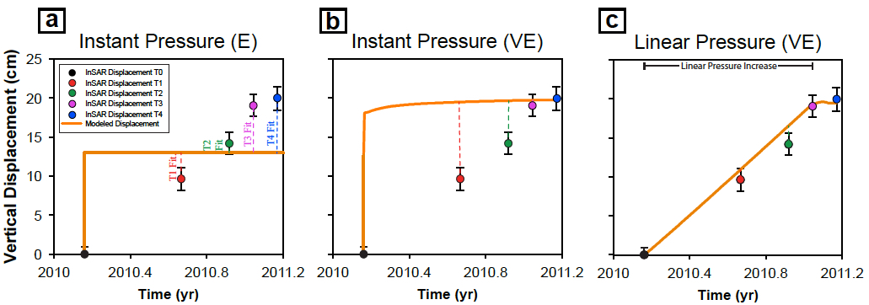

**Figure S8.** Illustration to show the residuals (dashed lines) between the observed and modeled displacement for one point in the surface and at each time step for: (a) instant overpressure at time 0 within an elastic medium, (b) instant overpressure at time 0 within a viscoelastic medium, and (c) linear pressure increase during 323 days within a viscoelastic medium. The source depth and overpressure for (a-c) are respectively 5 km and 40 MPa. Viscoelastic deformation in (b) and (c) result from the *EA1 AD1* hot model. The small residuals of the linear pressure model clearly show a better fit than the commonly used instant pressure assumption.

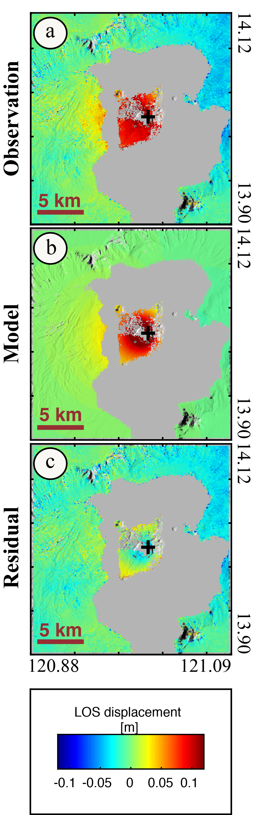

Figure S9. (a) LOS displacement from February 28, 2010 to March 3 2011. (b) Predicted LOS displacement from the best-fitting model for the same period. (c) Difference between the observed and predicted LOS displacement (residuals). Black cross: Mogi source center location.



Figure S10. Probability density distributions and trade-offs for the parameters of the best-fitting Mogi source. xE: Easting coordinate system of the subset. xN: Northing coordinate system of the subset. Depth of the source is expressed with respect to sea level. Strength of the source is expressed as volume change. Gibbs sampling with 100,000 sweeps at a critical temperature of -1. Dashed vertical line denotes the best-fit.

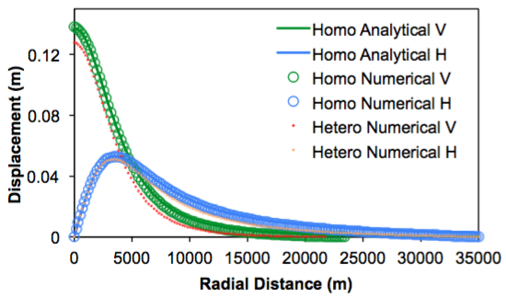

Figure S11. Comparisons between the analytical and numerical solutions of the vertical and horizontal displacements for the homogeneous elastic solution with the best-fitting heterogeneous elastic solution (source at 5 km with 40 MPa overpressure). Green line: analytical solution for vertical displacement within elastically homogeneous medium. Blue line: analytical solution for horizontal displacement within elastically homogeneous medium. Green circle: numerical solution for vertical displacement within elastically homogeneous medium. Blue circle: numerical solution for horizontal displacement within elastically homogeneous medium. Red dot: numerical solution for vertical displacement within elastically heterogeneous (in the vertical component) medium. Orange dot: numerical solution for vertical displacement within elastically heterogeneous (in the vertical component) medium.

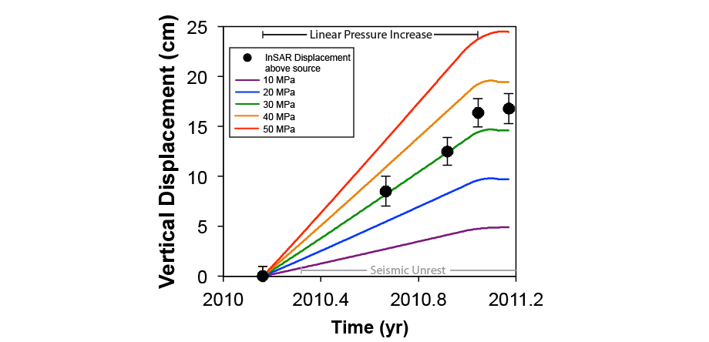

Figure S12. Modeled viscoelastic deformation at the surface (directly above the source center) for the *EA1 AD1* hot model with a spheroidal source (1 km radius) centered at 5 km depth and source overpressure rates of 10, 20, 30, 40, and 50 MPa/323 days, plotted against InSAR displacement time series (for pixel above the source) for the period of deformation.



Figure S13. Viscosity distributions calculated from the Arrhenius formulation for the cold and hot models, with a spheroidal source (1 km radius) centered at 5 km depth, and the indicated parameter combinations (*EA1*: 106 kJ/mol activation energy; *EA2*: 219 kJ/mol activation energy; *EA3*: 260 kJ/mol activation energy; *AD1*: 5*109 Pa*s Dorn parameter; *AD2*: 2*1013 Pa*s Dorn parameter; *AD3*: 3.2*1015 Pa*s Dorn parameter). Figures a, c, e, g, and i were calculated with a thermal gradient of 15 K/km. Figures b, d, f, h, and j were calculated with a thermal gradient of 100 K/km in the upper 4 km, and 35 K/km deeper than 4 km.

|  |  |  |
| --- | --- | --- |
| **ALOS-1 Ascending Track 449, Frames 260 and 270** | | |
| 02/20/2007 | 08/25/2008 | 01/13/2010 |
| 07/08/2007 | 10/10/2008 | 02/28/2010 |
| 08/23/2007 | 11/25/2008 | 08/31/2010 |
| 11/23/2007 | 01/10/2009 | 10/16/2010 |
| 01/08/2008 | 02/25/2009 | 12/01/2010 |
| 02/23/2008 | 07/13/2009 | 01/16/2011 |
| 04/09/2008 | 08/28/2009 | 03/03/2011 |
| 05/25/2008 | 10/13/2009 |  |
| 07/10/2008 | 11/28/2009 |  |

Table S1. List of available SAR scene dates over Taal (date format: mm/dd/yyyy). The satellite platform (ALOS-1), orbit direction (ascending), track number (449), and frame numbers (260 and 270) are shown in bold.

|  |  |  |
| --- | --- | --- |
| 070220-080710 | 080710-090713 | 100113-101201 |
| 070708-080710 | 080825-090225 | 100831-101016 |
| 070823-080710 | 090110-090713 | 101016-101201 |
| 080409-090828 | 090110-091013 | 101016-110116 |
| 080525-090713 | 090225-091013 | 101016-110303 |
| 080525-090828 | 090828-100228 |  |

Table S2. List of eliminated interferograms (date format: yymmdd).

|  |  |  |
| --- | --- | --- |
| 070220-070708 | 080409-080525 | 090828-091128 |
| 070708-070823 | 080710-081010 | 091013-091128 |
| 070708-071123 | 080710-081125 | 091013-100113 |
| 070708-080223 | 080710-090110 | 091128-100113 |
| 070708-080409 | 080825-081010 | 091128-100228 |
| 070823-071123 | 081010-081125 | 100113-100228 |
| 070823-080108 | 081010-090225 | 100228-100831 |
| 071123-080108 | 081125-090110 | 100228-101201 |
| 071123-080223 | 081125-090225 | 100831-101201 |
| 080108-080223 | 090110-090225 | 100831-110303 |
| 080108-080525 | 090225-100113 | 101201-110116 |
| 080108-080710 | 090713-090828 | 101201-110303 |
| 080223-080409 | 090713-091013 | 110116-110303 |
| 080223-080525 | 090828-091013 |  |

Table S3. List of inverted interferograms (date format: yymmdd).

|  |  |
| --- | --- |
| Taal volcano - Mogi Model | |
| **Deptha (km)**: 3.1 ± 1.1 [0.1 to 10.0]  **Latitude, Longitude (°)**: 14.0131, 121.0023 | **Volume Change (106 m3)**: 6.1 ± 3.1 [0.0 to 25.0] |
| InSAR data: 02/28/2010-03/03/2011 LOS displacement for ALOS-1 Track 449  Subset (N, W; S, E): 14.12°, 120.878°; 13.9027°, 121.0893°  RMSE (mm): 17.9  *aDepth of mogi source center, expressed with respect to Taal volcano summit (311 m a.s.l.).* | |

Table S4. Best-fitting source parameters with one sigma confidence intervals for InSAR detected deformation at Taal volcano. The range of modeled parameters are shown in the brackets.

|  |  |  |  |  |  |
| --- | --- | --- | --- | --- | --- |
| **Z (km)** | **ρ (kg/m3)** | **ν** | **E (GPa)** | **G (GPa)** | **K (GPa)** |
| **1 to -4** | 2465 | 0.2197 | 22.16 | 9.08 | 13.18 |

Table S5. Static elastic parameters for homogeneous model (average for upper 5 km from Table 1 of the manuscript).

***Elastic***

|  |  |  |  |  |  |  |  |  |  |  |
| --- | --- | --- | --- | --- | --- | --- | --- | --- | --- | --- |
| 2 km | | | | | | | | | | |
| **Geotherm** | **Pressure**  **(MPa)** | ***EA1 AD1***  **RMSE (mm)** | ***EA1 AD2***  **RMSE (mm)** | ***EA1 AD3***  **RMSE (mm)** | ***EA2 AD1***  **RMSE (mm)** | ***EA2 AD2***  **RMSE (mm)** | ***EA2 AD3***  **RMSE (mm)** | ***EA3 AD1***  **RMSE (mm)** | ***EA3 AD2***  **RMSE (mm)** | ***EA3 AD3***  **RMSE (mm)** |
| ***Cold*** | ***10*** | 52.85 | 52.85 | 52.85 | 52.85 | 52.85 | 52.85 | 52.85 | 52.85 | 52.85 |
| ***20*** | 131.42 | 131.42 | 131.42 | 131.42 | 131.42 | 131.42 | 131.42 | 131.42 | 131.42 |
| ***30*** | 212.58 | 212.58 | 212.58 | 212.58 | 212.58 | 212.58 | 212.58 | 212.58 | 212.58 |
| ***40*** | 294.20 | 294.20 | 294.20 | 294.20 | 294.20 | 294.20 | 294.20 | 294.20 | 294.20 |
| ***50*** | 375.98 | 375.98 | 375.98 | 375.98 | 375.98 | 375.98 | 375.98 | 375.98 | 375.98 |
| ***Hot*** | ***10*** | 52.99 | 52.85 | 52.85 | 52.85 | 52.85 | 52.85 | 52.85 | 52.85 | 52.85 |
| ***20*** | 131.73 | 131.42 | 131.42 | 131.42 | 131.42 | 131.42 | 131.42 | 131.42 | 131.42 |
| ***30*** | 213.06 | 212.58 | 212.58 | 212.58 | 212.58 | 212.58 | 212.58 | 212.58 | 212.58 |
| ***40*** | 294.84 | 294.20 | 294.20 | 294.20 | 294.20 | 294.20 | 294.20 | 294.20 | 294.20 |
| ***50*** | 376.78 | 375.98 | 375.98 | 375.98 | 375.98 | 375.98 | 375.98 | 375.98 | 375.98 |

|  |  |  |  |  |  |  |  |  |  |  |
| --- | --- | --- | --- | --- | --- | --- | --- | --- | --- | --- |
| 3 km | | | | | | | | | | |
| **Geotherm** | **Pressure**  **(MPa)** | ***EA1 AD1***  **RMSE (mm)** | ***EA1 AD2***  **RMSE (mm)** | ***EA1 AD3***  **RMSE (mm)** | ***EA2 AD1***  **RMSE (mm)** | ***EA2 AD2***  **RMSE (mm)** | ***EA2 AD3***  **RMSE (mm)** | ***EA3 AD1***  **RMSE (mm)** | ***EA3 AD2***  **RMSE (mm)** | ***EA3 AD3***  **RMSE (mm)** |
| ***Cold*** | ***10*** | 19.06 | 19.06 | 19.06 | 19.06 | 19.06 | 19.06 | 19.06 | 19.06 | 19.06 |
| ***20*** | 34.38 | 34.38 | 34.38 | 34.38 | 34.38 | 34.38 | 34.38 | 34.38 | 34.38 |
| ***30*** | 62.65 | 62.65 | 62.65 | 62.65 | 62.65 | 62.65 | 62.65 | 62.65 | 62.65 |
| ***40*** | 92.69 | 92.69 | 92.69 | 92.69 | 92.69 | 92.69 | 92.69 | 92.69 | 92.69 |
| ***50*** | 123.22 | 123.22 | 123.22 | 123.22 | 123.22 | 123.22 | 123.22 | 123.22 | 123.22 |
| ***Hot*** | ***10*** | 19.05 | 19.06 | 19.06 | 19.06 | 19.06 | 19.06 | 19.06 | 19.06 | 19.06 |
| ***20*** | 34.50 | 34.38 | 34.38 | 34.38 | 34.38 | 34.38 | 34.38 | 34.38 | 34.38 |
| ***30*** | 62.83 | 62.65 | 62.65 | 62.65 | 62.65 | 62.65 | 62.65 | 62.65 | 62.65 |
| ***40*** | 92.99 | 92.69 | 92.69 | 92.69 | 92.69 | 92.69 | 92.69 | 92.69 | 92.69 |
| ***50*** | 123.60 | 123.22 | 123.22 | 123.22 | 123.22 | 123.22 | 123.22 | 123.22 | 123.22 |

|  |  |  |  |  |  |  |  |  |  |  |
| --- | --- | --- | --- | --- | --- | --- | --- | --- | --- | --- |
| 4 km | | | | | | | | | | |
| **Geotherm** | **Pressure**  **(MPa)** | ***EA1 AD1***  **RMSE (mm)** | ***EA1 AD2***  **RMSE (mm)** | ***EA1 AD3***  **RMSE (mm)** | ***EA2 AD1***  **RMSE (mm)** | ***EA2 AD2***  **RMSE (mm)** | ***EA2 AD3***  **RMSE (mm)** | ***EA3 AD1***  **RMSE (mm)** | ***EA3 AD2***  **RMSE (mm)** | ***EA3 AD3***  **RMSE (mm)** |
| ***Cold*** | ***10*** | 22.37 | 22.37 | 22.37 | 22.37 | 22.37 | 22.37 | 22.37 | 22.37 | 22.37 |
| ***20*** | 16.02 | 16.02 | 16.02 | 16.02 | 16.02 | 16.02 | 16.02 | 16.02 | 16.02 |
| ***30*** | 23.83 | 23.83 | 23.83 | 23.83 | 23.83 | 23.83 | 23.83 | 23.83 | 23.83 |
| ***40*** | 37.88 | 37.88 | 37.88 | 37.88 | 37.88 | 37.88 | 37.88 | 37.88 | 37.88 |
| ***50*** | 53.45 | 53.45 | 53.45 | 53.45 | 53.45 | 53.45 | 53.45 | 53.45 | 53.45 |
| ***Hot*** | ***10*** | 22.34 | 22.37 | 22.37 | 22.37 | 22.37 | 22.37 | 22.37 | 22.37 | 22.37 |
| ***20*** | 16.02 | 16.02 | 16.02 | 16.02 | 16.02 | 16.02 | 16.02 | 16.02 | 16.02 |
| ***30*** | 23.94 | 23.83 | 23.83 | 23.83 | 23.83 | 23.83 | 23.83 | 23.83 | 23.83 |
| ***40*** | 38.05 | 37.88 | 37.88 | 37.88 | 37.88 | 37.88 | 37.88 | 37.88 | 37.88 |
| ***50*** | 53.68 | 53.45 | 53.45 | 53.45 | 53.45 | 53.45 | 53.45 | 53.45 | 53.45 |

|  |  |  |  |  |  |  |  |  |  |  |
| --- | --- | --- | --- | --- | --- | --- | --- | --- | --- | --- |
| 5 km | | | | | | | | | | |
| **Geotherm** | **Pressure**  **(MPa)** | ***EA1 AD1***  **RMSE (mm)** | ***EA1 AD2***  **RMSE (mm)** | ***EA1 AD3***  **RMSE (mm)** | ***EA2 AD1***  **RMSE (mm)** | ***EA2 AD2***  **RMSE (mm)** | ***EA2 AD3***  **RMSE (mm)** | ***EA3 AD1***  **RMSE (mm)** | ***EA3 AD2***  **RMSE (mm)** | ***EA3 AD3***  **RMSE (mm)** |
| ***Cold*** | ***10*** | 25.57 | 25.57 | 25.57 | 25.57 | 25.57 | 25.57 | 25.57 | 25.57 | 25.57 |
| ***20*** | 18.00 | 18.00 | 18.00 | 18.00 | 18.00 | 18.00 | 18.00 | 18.00 | 18.00 |
| ***30*** | 13.63 | 13.63 | 13.63 | 13.63 | 13.63 | 13.63 | 13.63 | 13.63 | 13.63 |
| ***40*** | 15.45 | 15.45 | 15.45 | 15.45 | 15.45 | 15.45 | 15.45 | 15.45 | 15.45 |
| ***50*** | 21.97 | 21.97 | 21.97 | 21.97 | 21.97 | 21.97 | 21.97 | 21.97 | 21.97 |
| ***Hot*** | ***10*** | 25.54 | 25.57 | 25.57 | 25.57 | 25.57 | 25.57 | 25.57 | 25.57 | 25.57 |
| ***20*** | 17.95 | 18.00 | 18.00 | 18.00 | 18.00 | 18.00 | 18.00 | 18.00 | 18.00 |
| ***30*** | 13.61 | 13.63 | 13.63 | 13.63 | 13.63 | 13.63 | 13.63 | 13.63 | 13.63 |
| ***40*** | 15.51 | 15.45 | 15.45 | 15.45 | 15.45 | 15.45 | 15.45 | 15.45 | 15.45 |
| ***50*** | 22.11 | 21.97 | 21.97 | 21.97 | 21.97 | 21.97 | 21.97 | 21.97 | 21.97 |

**Table S6**. RMSE estimates for fit of modeled instant (elastic) displacement to observed InSAR displacement at 185 days (source at 2-5 km depth; instant pressure model).

***Viscoelastic***

|  |  |  |  |  |  |  |  |  |  |  |
| --- | --- | --- | --- | --- | --- | --- | --- | --- | --- | --- |
| 2 km | | | | | | | | | | |
| **Geotherm** | **Pressure**  **(MPa)** | ***EA1 AD1***  **RMSE (mm)** | ***EA1 AD2***  **RMSE (mm)** | ***EA1 AD3***  **RMSE (mm)** | ***EA2 AD1***  **RMSE (mm)** | ***EA2 AD2***  **RMSE (mm)** | ***EA2 AD3***  **RMSE (mm)** | ***EA3 AD1***  **RMSE (mm)** | ***EA3 AD2***  **RMSE (mm)** | ***EA3 AD3***  **RMSE (mm)** |
| ***Cold*** | ***10*** | 72.85 | 52.88 | 52.85 | 52.85 | 52.85 | 52.85 | 52.85 | 52.85 | 52.85 |
| ***20*** | 174.07 | 131.48 | 131.42 | 131.42 | 131.42 | 131.42 | 131.42 | 131.42 | 131.42 |
| ***30*** | 277.02 | 212.67 | 212.58 | 212.58 | 212.58 | 212.58 | 212.58 | 212.58 | 212.58 |
| ***40*** | 380.29 | 294.32 | 294.20 | 294.20 | 294.20 | 294.20 | 294.20 | 294.20 | 294.20 |
| ***50*** | 483.68 | 376.13 | 375.98 | 375.98 | 375.98 | 375.98 | 375.98 | 375.98 | 375.98 |
| ***Hot*** | ***10*** | 94.69 | 59.84 | 52.91 | 57.47 | 52.85 | 52.85 | 53.12 | 52.85 | 52.85 |
| ***20*** | 219.51 | 146.65 | 131.54 | 141.52 | 131.42 | 131.42 | 132.02 | 131.42 | 131.42 |
| ***30*** | 345.56 | 235.66 | 212.77 | 227.89 | 212.59 | 212.58 | 213.49 | 212.58 | 212.58 |
| ***40*** | 471.85 | 325.07 | 294.45 | 314.67 | 294.21 | 294.20 | 295.42 | 294.20 | 294.20 |
| ***50*** | 598.24 | 414.62 | 376.29 | 401.60 | 375.99 | 375.98 | 377.51 | 375.98 | 375.98 |

|  |  |  |  |  |  |  |  |  |  |  |
| --- | --- | --- | --- | --- | --- | --- | --- | --- | --- | --- |
| 3 km | | | | | | | | | | |
| **Geotherm** | **Pressure**  **(MPa)** | ***EA1 AD1***  **RMSE (mm)** | ***EA1 AD2***  **RMSE (mm)** | ***EA1 AD3***  **RMSE (mm)** | ***EA2 AD1***  **RMSE (mm)** | ***EA2 AD2***  **RMSE (mm)** | ***EA2 AD3***  **RMSE (mm)** | ***EA3 AD1***  **RMSE (mm)** | ***EA3 AD2***  **RMSE (mm)** | ***EA3 AD3***  **RMSE (mm)** |
| ***Cold*** | ***10*** | 19.94 | 19.06 | 19.06 | 19.06 | 19.06 | 19.06 | 19.06 | 19.06 | 19.06 |
| ***20*** | 49.67 | 34.40 | 34.38 | 34.38 | 34.38 | 34.38 | 34.38 | 34.38 | 34.38 |
| ***30*** | 87.61 | 62.69 | 62.65 | 62.65 | 62.65 | 62.65 | 62.65 | 62.65 | 62.65 |
| ***40*** | 126.59 | 92.75 | 92.69 | 92.69 | 92.69 | 92.69 | 92.69 | 92.69 | 92.69 |
| ***50*** | 165.88 | 123.29 | 123.22 | 123.22 | 123.22 | 123.22 | 123.22 | 123.22 | 123.22 |
| ***Hot*** | ***10*** | 22.57 | 18.88 | 19.05 | 18.87 | 19.06 | 19.06 | 19.03 | 19.06 | 19.06 |
| ***20*** | 62.57 | 40.46 | 34.43 | 38.46 | 34.38 | 34.38 | 34.63 | 34.38 | 34.38 |
| ***30*** | 108.11 | 72.87 | 62.73 | 69.55 | 62.65 | 62.65 | 63.08 | 62.65 | 62.65 |
| ***40*** | 154.35 | 106.66 | 92.81 | 102.13 | 92.69 | 92.69 | 93.29 | 92.69 | 92.69 |
| ***50*** | 200.81 | 140.84 | 123.37 | 135.13 | 123.22 | 123.22 | 123.98 | 123.22 | 123.22 |

|  |  |  |  |  |  |  |  |  |  |  |
| --- | --- | --- | --- | --- | --- | --- | --- | --- | --- | --- |
| 4 km | | | | | | | | | | |
| **Geotherm** | **Pressure**  **(MPa)** | ***EA1 AD1***  **RMSE (mm)** | ***EA1 AD2***  **RMSE (mm)** | ***EA1 AD3***  **RMSE (mm)** | ***EA2 AD1***  **RMSE (mm)** | ***EA2 AD2***  **RMSE (mm)** | ***EA2 AD3***  **RMSE (mm)** | ***EA3 AD1***  **RMSE (mm)** | ***EA3 AD2***  **RMSE (mm)** | ***EA3 AD3***  **RMSE (mm)** |
| ***Cold*** | ***10*** | 19.32 | 22.37 | 22.37 | 22.37 | 22.37 | 22.37 | 22.37 | 22.37 | 22.37 |
| ***20*** | 19.08 | 16.02 | 16.02 | 16.02 | 16.02 | 16.02 | 16.02 | 16.02 | 16.02 |
| ***30*** | 35.67 | 23.85 | 23.83 | 23.83 | 23.83 | 23.83 | 23.83 | 23.83 | 23.83 |
| ***40*** | 55.66 | 37.91 | 37.88 | 37.88 | 37.88 | 37.88 | 37.88 | 37.88 | 37.88 |
| ***50*** | 76.43 | 53.49 | 53.45 | 53.45 | 53.45 | 53.45 | 53.45 | 53.45 | 53.45 |
| ***Hot*** | ***10*** | 16.88 | 20.85 | 22.36 | 21.32 | 22.37 | 22.37 | 22.30 | 22.37 | 22.37 |
| ***20*** | 23.65 | 16.72 | 16.02 | 16.39 | 16.02 | 16.02 | 16.02 | 16.02 | 16.02 |
| ***30*** | 46.09 | 28.89 | 23.87 | 27.25 | 23.83 | 23.83 | 24.04 | 23.83 | 23.83 |
| ***40*** | 70.56 | 45.82 | 37.95 | 43.31 | 37.88 | 37.88 | 38.23 | 37.88 | 37.88 |
| ***50*** | 95.52 | 63.83 | 53.54 | 60.57 | 53.46 | 53.45 | 53.92 | 53.45 | 53.45 |

|  |  |  |  |  |  |  |  |  |  |  |
| --- | --- | --- | --- | --- | --- | --- | --- | --- | --- | --- |
| 5 km | | | | | | | | | | |
| **Geotherm** | **Pressure**  **(MPa)** | ***EA1 AD1***  **RMSE (mm)** | ***EA1 AD2***  **RMSE (mm)** | ***EA1 AD3***  **RMSE (mm)** | ***EA2 AD1***  **RMSE (mm)** | ***EA2 AD2***  **RMSE (mm)** | ***EA2 AD3***  **RMSE (mm)** | ***EA3 AD1***  **RMSE (mm)** | ***EA3 AD2***  **RMSE (mm)** | ***EA3 AD3***  **RMSE (mm)** |
| ***Cold*** | ***10*** | 23.06 | 25.56 | 25.57 | 25.57 | 25.57 | 25.57 | 25.57 | 25.57 | 25.57 |
| ***20*** | 14.67 | 17.99 | 18.00 | 18.00 | 18.00 | 18.00 | 18.00 | 18.00 | 18.00 |
| ***30*** | 14.99 | 13.63 | 13.63 | 13.63 | 13.63 | 13.63 | 13.63 | 13.63 | 13.63 |
| ***40*** | 23.67 | 15.46 | 15.45 | 15.45 | 15.45 | 15.45 | 15.45 | 15.45 | 15.45 |
| ***50*** | 34.96 | 22.00 | 21.97 | 21.97 | 21.97 | 21.97 | 21.97 | 21.97 | 21.97 |
| ***Hot*** | ***10*** | 20.82 | 24.27 | 25.55 | 24.67 | 25.57 | 25.57 | 25.50 | 25.57 | 25.57 |
| ***20*** | 12.61 | 16.08 | 17.98 | 16.64 | 18.00 | 18.00 | 17.90 | 18.00 | 18.00 |
| ***30*** | 18.75 | 13.54 | 13.62 | 13.42 | 13.63 | 13.63 | 13.58 | 13.63 | 13.63 |
| ***40*** | 31.80 | 19.07 | 15.47 | 17.82 | 15.45 | 15.45 | 15.58 | 15.45 | 15.45 |
| ***50*** | 46.23 | 28.27 | 22.03 | 26.26 | 21.97 | 21.97 | 22.25 | 21.97 | 21.97 |

**Table S7**. RMSE estimates for fit of modeled viscoelastic displacement of 185 days to observed InSAR displacement at 185 days (source at 2-5 km depth; instant pressure model).

***Elastic***

|  |  |  |  |  |  |  |  |  |  |  |
| --- | --- | --- | --- | --- | --- | --- | --- | --- | --- | --- |
| 2 km | | | | | | | | | | |
| **Geotherm** | **Pressure**  **(MPa)** | ***EA1 AD1***  **RMSE (mm)** | ***EA1 AD2***  **RMSE (mm)** | ***EA1 AD3***  **RMSE (mm)** | ***EA2 AD1***  **RMSE (mm)** | ***EA2 AD2***  **RMSE (mm)** | ***EA2 AD3***  **RMSE (mm)** | ***EA3 AD1***  **RMSE (mm)** | ***EA3 AD2***  **RMSE (mm)** | ***EA3 AD3***  **RMSE (mm)** |
| ***Cold*** | ***10*** | 40.90 | 40.90 | 40.90 | 40.90 | 40.90 | 40.90 | 40.90 | 40.90 | 40.90 |
| ***20*** | 114.86 | 114.86 | 114.86 | 114.86 | 114.86 | 114.86 | 114.86 | 114.86 | 114.86 |
| ***30*** | 195.33 | 195.33 | 195.33 | 195.33 | 195.33 | 195.33 | 195.33 | 195.33 | 195.33 |
| ***40*** | 276.70 | 276.69 | 276.69 | 276.69 | 276.69 | 276.69 | 276.69 | 276.69 | 276.69 |
| ***50*** | 358.34 | 358.34 | 358.34 | 358.34 | 358.34 | 358.34 | 358.34 | 358.34 | 358.34 |
| ***Hot*** | ***10*** | 41.01 | 40.90 | 40.90 | 40.90 | 40.90 | 40.90 | 40.90 | 40.90 | 40.90 |
| ***20*** | 115.17 | 114.86 | 114.86 | 114.86 | 114.86 | 114.86 | 114.86 | 114.86 | 114.86 |
| ***30*** | 195.81 | 195.33 | 195.33 | 195.33 | 195.33 | 195.33 | 195.33 | 195.33 | 195.33 |
| ***40*** | 277.33 | 276.69 | 276.69 | 276.69 | 276.69 | 276.69 | 276.69 | 276.69 | 276.69 |
| ***50*** | 359.14 | 358.34 | 358.34 | 358.34 | 358.34 | 358.34 | 358.34 | 358.34 | 358.34 |

|  |  |  |  |  |  |  |  |  |  |  |
| --- | --- | --- | --- | --- | --- | --- | --- | --- | --- | --- |
| 3 km | | | | | | | | | | |
| **Geotherm** | **Pressure**  **(MPa)** | ***EA1 AD1***  **RMSE (mm)** | ***EA1 AD2***  **RMSE (mm)** | ***EA1 AD3***  **RMSE (mm)** | ***EA2 AD1***  **RMSE (mm)** | ***EA2 AD2***  **RMSE (mm)** | ***EA2 AD3***  **RMSE (mm)** | ***EA3 AD1***  **RMSE (mm)** | ***EA3 AD2***  **RMSE (mm)** | ***EA3 AD3***  **RMSE (mm)** |
| ***Cold*** | ***10*** | 27.56 | 27.56 | 27.56 | 27.56 | 27.56 | 27.56 | 27.56 | 27.56 | 27.56 |
| ***20*** | 23.39 | 23.39 | 23.39 | 23.39 | 23.39 | 23.39 | 23.39 | 23.39 | 23.39 |
| ***30*** | 47.52 | 47.52 | 47.52 | 47.52 | 47.52 | 47.52 | 47.52 | 47.52 | 47.52 |
| ***40*** | 76.78 | 76.78 | 76.78 | 76.78 | 76.78 | 76.78 | 76.78 | 76.78 | 76.78 |
| ***50*** | 107.03 | 107.03 | 107.03 | 107.03 | 107.03 | 107.03 | 107.03 | 107.03 | 107.03 |
| ***Hot*** | ***10*** | 27.51 | 27.56 | 27.56 | 27.56 | 27.56 | 27.56 | 27.56 | 27.56 | 27.56 |
| ***20*** | 23.47 | 23.39 | 23.39 | 23.39 | 23.39 | 23.39 | 23.39 | 23.39 | 23.39 |
| ***30*** | 47.73 | 47.52 | 47.52 | 47.52 | 47.52 | 47.52 | 47.52 | 47.52 | 47.52 |
| ***40*** | 77.07 | 76.78 | 76.78 | 76.78 | 76.78 | 76.78 | 76.78 | 76.78 | 76.78 |
| ***50*** | 107.40 | 107.03 | 107.03 | 107.03 | 107.03 | 107.03 | 107.03 | 107.03 | 107.03 |

|  |  |  |  |  |  |  |  |  |  |  |
| --- | --- | --- | --- | --- | --- | --- | --- | --- | --- | --- |
| 4 km | | | | | | | | | | |
| **Geotherm** | **Pressure**  **(MPa)** | ***EA1 AD1***  **RMSE (mm)** | ***EA1 AD2***  **RMSE (mm)** | ***EA1 AD3***  **RMSE (mm)** | ***EA2 AD1***  **RMSE (mm)** | ***EA2 AD2***  **RMSE (mm)** | ***EA2 AD3***  **RMSE (mm)** | ***EA3 AD1***  **RMSE (mm)** | ***EA3 AD2***  **RMSE (mm)** | ***EA3 AD3***  **RMSE (mm)** |
| ***Cold*** | ***10*** | 34.57 | 34.57 | 34.57 | 34.57 | 34.57 | 34.57 | 34.57 | 34.57 | 34.57 |
| ***20*** | 21.41 | 21.41 | 21.41 | 21.41 | 21.41 | 21.41 | 21.41 | 21.41 | 21.41 |
| ***30*** | 16.64 | 16.64 | 16.64 | 16.64 | 16.64 | 16.64 | 16.64 | 16.64 | 16.64 |
| ***40*** | 25.51 | 25.51 | 25.51 | 25.51 | 25.51 | 25.51 | 25.51 | 25.51 | 25.51 |
| ***50*** | 39.76 | 39.76 | 39.76 | 39.76 | 39.76 | 39.76 | 39.76 | 39.76 | 39.76 |
| ***Hot*** | ***10*** | 34.53 | 34.57 | 34.57 | 34.57 | 34.57 | 34.57 | 34.57 | 34.57 | 34.57 |
| ***20*** | 21.34 | 21.41 | 21.41 | 21.41 | 21.41 | 21.41 | 21.41 | 21.41 | 21.41 |
| ***30*** | 16.66 | 16.64 | 16.64 | 16.64 | 16.64 | 16.64 | 16.64 | 16.64 | 16.64 |
| ***40*** | 25.66 | 25.51 | 25.51 | 25.51 | 25.51 | 25.51 | 25.51 | 25.51 | 25.51 |
| ***50*** | 39.97 | 39.76 | 39.76 | 39.76 | 39.76 | 39.76 | 39.76 | 39.76 | 39.76 |

|  |  |  |  |  |  |  |  |  |  |  |
| --- | --- | --- | --- | --- | --- | --- | --- | --- | --- | --- |
| 5 km | | | | | | | | | | |
| **Geotherm** | **Pressure**  **(MPa)** | ***EA1 AD1***  **RMSE (mm)** | ***EA1 AD2***  **RMSE (mm)** | ***EA1 AD3***  **RMSE (mm)** | ***EA2 AD1***  **RMSE (mm)** | ***EA2 AD2***  **RMSE (mm)** | ***EA2 AD3***  **RMSE (mm)** | ***EA3 AD1***  **RMSE (mm)** | ***EA3 AD2***  **RMSE (mm)** | ***EA3 AD3***  **RMSE (mm)** |
| ***Cold*** | ***10*** | 37.63 | 37.63 | 37.63 | 37.63 | 37.63 | 37.63 | 37.63 | 37.63 | 37.63 |
| ***20*** | 29.00 | 29.00 | 29.00 | 29.00 | 29.00 | 29.00 | 29.00 | 29.00 | 29.00 |
| ***30*** | 21.40 | 21.40 | 21.40 | 21.40 | 21.40 | 21.40 | 21.40 | 21.40 | 21.40 |
| ***40*** | 16.31 | 16.31 | 16.31 | 16.31 | 16.31 | 16.31 | 16.31 | 16.31 | 16.31 |
| ***50*** | 16.28 | 16.28 | 16.28 | 16.28 | 16.28 | 16.28 | 16.28 | 16.28 | 16.28 |
| ***Hot*** | ***10*** | 37.59 | 37.63 | 37.63 | 37.63 | 37.63 | 37.63 | 37.63 | 37.63 | 37.63 |
| ***20*** | 28.94 | 29.00 | 29.00 | 29.00 | 29.00 | 29.00 | 29.00 | 29.00 | 29.00 |
| ***30*** | 21.33 | 21.40 | 21.40 | 21.40 | 21.40 | 21.40 | 21.40 | 21.40 | 21.40 |
| ***40*** | 16.27 | 16.31 | 16.31 | 16.31 | 16.31 | 16.31 | 16.31 | 16.31 | 16.31 |
| ***50*** | 16.33 | 16.28 | 16.28 | 16.28 | 16.28 | 16.28 | 16.28 | 16.28 | 16.28 |

**Table S8**. RMSE estimates for fit of modeled instant (elastic) displacement to observed InSAR displacement at 277 days (source at 2-5 km depth; instant pressure model).

***Viscoelastic***

|  |  |  |  |  |  |  |  |  |  |  |
| --- | --- | --- | --- | --- | --- | --- | --- | --- | --- | --- |
| 2 km | | | | | | | | | | |
| **Geotherm** | **Pressure**  **(MPa)** | ***EA1 AD1***  **RMSE (mm)** | ***EA1 AD2***  **RMSE (mm)** | ***EA1 AD3***  **RMSE (mm)** | ***EA2 AD1***  **RMSE (mm)** | ***EA2 AD2***  **RMSE (mm)** | ***EA2 AD3***  **RMSE (mm)** | ***EA3 AD1***  **RMSE (mm)** | ***EA3 AD2***  **RMSE (mm)** | ***EA3 AD3***  **RMSE (mm)** |
| ***Cold*** | ***10*** | 60.29 | 40.93 | 40.90 | 40.90 | 40.90 | 40.90 | 40.90 | 40.90 | 40.90 |
| ***20*** | 161.22 | 114.94 | 114.86 | 114.86 | 114.86 | 114.86 | 114.86 | 114.86 | 114.86 |
| ***30*** | 265.83 | 195.46 | 195.33 | 195.33 | 195.33 | 195.33 | 195.33 | 195.33 | 195.33 |
| ***40*** | 371.02 | 276.88 | 276.69 | 276.69 | 276.69 | 276.69 | 276.69 | 276.69 | 276.69 |
| ***50*** | 476.41 | 358.57 | 358.34 | 358.34 | 358.34 | 358.34 | 358.34 | 358.34 | 358.34 |
| ***Hot*** | ***10*** | 79.87 | 48.80 | 40.97 | 45.99 | 40.90 | 40.90 | 41.22 | 40.90 | 40.90 |
| ***20*** | 204.04 | 135.00 | 115.04 | 128.07 | 114.86 | 114.86 | 115.73 | 114.86 | 114.86 |
| ***30*** | 330.69 | 226.11 | 195.61 | 215.53 | 195.34 | 195.33 | 196.68 | 195.33 | 195.33 |
| ***40*** | 457.77 | 317.94 | 277.07 | 303.77 | 276.70 | 276.69 | 278.50 | 276.69 | 276.69 |
| ***50*** | 584.99 | 410.03 | 358.81 | 392.26 | 358.35 | 358.34 | 360.61 | 358.34 | 358.34 |

|  |  |  |  |  |  |  |  |  |  |  |
| --- | --- | --- | --- | --- | --- | --- | --- | --- | --- | --- |
| 3 km | | | | | | | | | | |
| **Geotherm** | **Pressure**  **(MPa)** | ***EA1 AD1***  **RMSE (mm)** | ***EA1 AD2***  **RMSE (mm)** | ***EA1 AD3***  **RMSE (mm)** | ***EA2 AD1***  **RMSE (mm)** | ***EA2 AD2***  **RMSE (mm)** | ***EA2 AD3***  **RMSE (mm)** | ***EA3 AD1***  **RMSE (mm)** | ***EA3 AD2***  **RMSE (mm)** | ***EA3 AD3***  **RMSE (mm)** |
| ***Cold*** | ***10*** | 22.25 | 27.55 | 27.56 | 27.56 | 27.56 | 27.56 | 27.56 | 27.56 | 27.56 |
| ***20*** | 36.69 | 23.41 | 23.39 | 23.39 | 23.39 | 23.39 | 23.39 | 23.39 | 23.39 |
| ***30*** | 73.83 | 47.58 | 47.52 | 47.52 | 47.52 | 47.52 | 47.52 | 47.52 | 47.52 |
| ***40*** | 113.18 | 76.86 | 76.78 | 76.78 | 76.78 | 76.78 | 76.78 | 76.78 | 76.78 |
| ***50*** | 153.04 | 107.13 | 107.03 | 107.03 | 107.03 | 107.03 | 107.03 | 107.03 | 107.03 |
| ***Hot*** | ***10*** | 19.76 | 24.52 | 27.53 | 25.49 | 27.56 | 27.56 | 27.40 | 27.56 | 27.56 |
| ***20*** | 48.21 | 29.29 | 23.43 | 27.12 | 23.39 | 23.39 | 23.62 | 23.39 | 23.39 |
| ***30*** | 93.26 | 60.54 | 47.65 | 56.17 | 47.53 | 47.52 | 48.14 | 47.52 | 47.52 |
| ***40*** | 139.68 | 95.00 | 76.95 | 88.92 | 76.78 | 76.78 | 77.66 | 76.78 | 76.78 |
| ***50*** | 186.45 | 130.15 | 107.25 | 122.44 | 107.03 | 107.03 | 108.15 | 107.03 | 107.03 |

|  |  |  |  |  |  |  |  |  |  |  |
| --- | --- | --- | --- | --- | --- | --- | --- | --- | --- | --- |
| 4 km | | | | | | | | | | |
| **Geotherm** | **Pressure**  **(MPa)** | ***EA1 AD1***  **RMSE (mm)** | ***EA1 AD2***  **RMSE (mm)** | ***EA1 AD3***  **RMSE (mm)** | ***EA2 AD1***  **RMSE (mm)** | ***EA2 AD2***  **RMSE (mm)** | ***EA2 AD3***  **RMSE (mm)** | ***EA3 AD1***  **RMSE (mm)** | ***EA3 AD2***  **RMSE (mm)** | ***EA3 AD3***  **RMSE (mm)** |
| ***Cold*** | ***10*** | 30.16 | 34.56 | 34.57 | 34.57 | 34.57 | 34.57 | 34.57 | 34.57 | 34.57 |
| ***20*** | 16.74 | 21.39 | 21.41 | 21.41 | 21.41 | 21.41 | 21.41 | 21.41 | 21.41 |
| ***30*** | 24.50 | 16.65 | 16.64 | 16.64 | 16.64 | 16.64 | 16.64 | 16.64 | 16.64 |
| ***40*** | 43.23 | 25.55 | 25.51 | 25.51 | 25.51 | 25.51 | 25.51 | 25.51 | 25.51 |
| ***50*** | 63.93 | 39.81 | 39.76 | 39.76 | 39.76 | 39.76 | 39.76 | 39.76 | 39.76 |
| ***Hot*** | ***10*** | 26.96 | 32.08 | 34.55 | 32.88 | 34.57 | 34.57 | 34.44 | 34.57 | 34.57 |
| ***20*** | 16.67 | 18.21 | 21.37 | 19.13 | 21.41 | 21.41 | 21.22 | 21.41 | 21.41 |
| ***30*** | 33.79 | 19.89 | 16.66 | 18.49 | 16.64 | 16.64 | 16.72 | 16.64 | 16.64 |
| ***40*** | 57.60 | 34.94 | 25.60 | 31.76 | 25.52 | 25.51 | 25.96 | 25.51 | 25.51 |
| ***50*** | 82.50 | 52.98 | 39.88 | 48.66 | 39.76 | 39.76 | 40.42 | 39.76 | 39.76 |

|  |  |  |  |  |  |  |  |  |  |  |
| --- | --- | --- | --- | --- | --- | --- | --- | --- | --- | --- |
| 5 km | | | | | | | | | | |
| **Geotherm** | **Pressure**  **(MPa)** | ***EA1 AD1***  **RMSE (mm)** | ***EA1 AD2***  **RMSE (mm)** | ***EA1 AD3***  **RMSE (mm)** | ***EA2 AD1***  **RMSE (mm)** | ***EA2 AD2***  **RMSE (mm)** | ***EA2 AD3***  **RMSE (mm)** | ***EA3 AD1***  **RMSE (mm)** | ***EA3 AD2***  **RMSE (mm)** | ***EA3 AD3***  **RMSE (mm)** |
| ***Cold*** | ***10*** | 34.73 | 37.62 | 37.63 | 37.63 | 37.63 | 37.63 | 37.63 | 37.63 | 37.63 |
| ***20*** | 23.84 | 28.99 | 29.00 | 29.00 | 29.00 | 29.00 | 29.00 | 29.00 | 29.00 |
| ***30*** | 16.36 | 21.38 | 21.40 | 21.40 | 21.40 | 21.40 | 21.40 | 21.40 | 21.40 |
| ***40*** | 17.44 | 16.30 | 16.31 | 16.31 | 16.31 | 16.31 | 16.31 | 16.31 | 16.31 |
| ***50*** | 26.04 | 16.30 | 16.28 | 16.28 | 16.28 | 16.28 | 16.28 | 16.28 | 16.28 |
| ***Hot*** | ***10*** | 32.65 | 35.85 | 37.61 | 36.41 | 37.63 | 37.63 | 37.53 | 37.63 | 37.63 |
| ***20*** | 20.63 | 25.78 | 28.97 | 26.78 | 29.00 | 29.00 | 28.82 | 29.00 | 29.00 |
| ***30*** | 16.11 | 17.88 | 21.36 | 18.87 | 21.40 | 21.40 | 21.18 | 21.40 | 21.40 |
| ***40*** | 23.84 | 15.82 | 16.28 | 15.55 | 16.31 | 16.31 | 16.18 | 16.31 | 16.31 |
| ***50*** | 36.76 | 21.36 | 16.31 | 19.36 | 16.28 | 16.28 | 16.45 | 16.28 | 16.28 |

**Table S9**. RMSE estimates for fit of modeled viscoelastic displacement of 277 days to observed InSAR displacement at 277 days (source at 2-5 km depth; instant pressure model).

***Elastic***

|  |  |  |  |  |  |  |  |  |  |  |
| --- | --- | --- | --- | --- | --- | --- | --- | --- | --- | --- |
| 2 km | | | | | | | | | | |
| **Geotherm** | **Pressure**  **(MPa)** | ***EA1 AD1***  **RMSE (mm)** | ***EA1 AD2***  **RMSE (mm)** | ***EA1 AD3***  **RMSE (mm)** | ***EA2 AD1***  **RMSE (mm)** | ***EA2 AD2***  **RMSE (mm)** | ***EA2 AD3***  **RMSE (mm)** | ***EA3 AD1***  **RMSE (mm)** | ***EA3 AD2***  **RMSE (mm)** | ***EA3 AD3***  **RMSE (mm)** |
| ***Cold*** | ***10*** | 46.97 | 46.97 | 46.97 | 46.97 | 46.97 | 46.97 | 46.97 | 46.97 | 46.97 |
| ***20*** | 104.36 | 104.36 | 104.36 | 104.36 | 104.36 | 104.36 | 104.36 | 104.36 | 104.36 |
| ***30*** | 181.71 | 181.71 | 181.71 | 181.71 | 181.71 | 181.71 | 181.71 | 181.71 | 181.71 |
| ***40*** | 261.90 | 261.89 | 261.89 | 261.89 | 261.89 | 261.89 | 261.89 | 261.89 | 261.89 |
| ***50*** | 342.93 | 342.93 | 342.93 | 342.93 | 342.93 | 342.93 | 342.93 | 342.93 | 342.93 |
| ***Hot*** | ***10*** | 47.01 | 46.97 | 46.97 | 46.97 | 46.97 | 46.97 | 46.97 | 46.97 | 46.97 |
| ***20*** | 104.64 | 104.36 | 104.36 | 104.36 | 104.36 | 104.36 | 104.36 | 104.36 | 104.36 |
| ***30*** | 182.17 | 181.71 | 181.71 | 181.71 | 181.71 | 181.71 | 181.71 | 181.71 | 181.71 |
| ***40*** | 262.52 | 261.89 | 261.89 | 261.89 | 261.89 | 261.89 | 261.89 | 261.89 | 261.89 |
| ***50*** | 343.73 | 342.93 | 342.93 | 342.93 | 342.93 | 342.93 | 342.93 | 342.93 | 342.93 |

|  |  |  |  |  |  |  |  |  |  |  |
| --- | --- | --- | --- | --- | --- | --- | --- | --- | --- | --- |
| 3 km | | | | | | | | | | |
| **Geotherm** | **Pressure**  **(MPa)** | ***EA1 AD1***  **RMSE (mm)** | ***EA1 AD2***  **RMSE (mm)** | ***EA1 AD3***  **RMSE (mm)** | ***EA2 AD1***  **RMSE (mm)** | ***EA2 AD2***  **RMSE (mm)** | ***EA2 AD3***  **RMSE (mm)** | ***EA3 AD1***  **RMSE (mm)** | ***EA3 AD2***  **RMSE (mm)** | ***EA3 AD3***  **RMSE (mm)** |
| ***Cold*** | ***10*** | 49.89 | 49.89 | 49.89 | 49.89 | 49.89 | 49.89 | 49.89 | 49.89 | 49.89 |
| ***20*** | 33.95 | 33.95 | 33.95 | 33.95 | 33.95 | 33.95 | 33.95 | 33.95 | 33.95 |
| ***30*** | 41.72 | 41.72 | 41.72 | 41.72 | 41.72 | 41.72 | 41.72 | 41.72 | 41.72 |
| ***40*** | 65.21 | 65.21 | 65.21 | 65.21 | 65.21 | 65.21 | 65.21 | 65.21 | 65.21 |
| ***50*** | 93.22 | 93.22 | 93.22 | 93.22 | 93.22 | 93.22 | 93.22 | 93.22 | 93.22 |
| ***Hot*** | ***10*** | 49.83 | 49.89 | 49.89 | 49.89 | 49.89 | 49.89 | 49.89 | 49.89 | 49.89 |
| ***20*** | 33.92 | 33.95 | 33.95 | 33.95 | 33.95 | 33.95 | 33.95 | 33.95 | 33.95 |
| ***30*** | 41.86 | 41.72 | 41.72 | 41.72 | 41.72 | 41.72 | 41.72 | 41.72 | 41.72 |
| ***40*** | 65.47 | 65.21 | 65.21 | 65.21 | 65.21 | 65.21 | 65.21 | 65.21 | 65.21 |
| ***50*** | 93.57 | 93.22 | 93.22 | 93.22 | 93.22 | 93.22 | 93.22 | 93.22 | 93.22 |

|  |  |  |  |  |  |  |  |  |  |  |
| --- | --- | --- | --- | --- | --- | --- | --- | --- | --- | --- |
| 4 km | | | | | | | | | | |
| **Geotherm** | **Pressure**  **(MPa)** | ***EA1 AD1***  **RMSE (mm)** | ***EA1 AD2***  **RMSE (mm)** | ***EA1 AD3***  **RMSE (mm)** | ***EA2 AD1***  **RMSE (mm)** | ***EA2 AD2***  **RMSE (mm)** | ***EA2 AD3***  **RMSE (mm)** | ***EA3 AD1***  **RMSE (mm)** | ***EA3 AD2***  **RMSE (mm)** | ***EA3 AD3***  **RMSE (mm)** |
| ***Cold*** | ***10*** | 55.37 | 55.37 | 55.37 | 55.37 | 55.37 | 55.37 | 55.37 | 55.37 | 55.37 |
| ***20*** | 41.40 | 41.40 | 41.40 | 41.40 | 41.40 | 41.40 | 41.40 | 41.40 | 41.40 |
| ***30*** | 30.28 | 30.28 | 30.28 | 30.28 | 30.28 | 30.28 | 30.28 | 30.28 | 30.28 |
| ***40*** | 25.99 | 25.99 | 25.99 | 25.99 | 25.99 | 25.99 | 25.99 | 25.99 | 25.99 |
| ***50*** | 31.45 | 31.45 | 31.45 | 31.45 | 31.45 | 31.45 | 31.45 | 31.45 | 31.45 |
| ***Hot*** | ***10*** | 55.33 | 55.37 | 55.37 | 55.37 | 55.37 | 55.37 | 55.37 | 55.37 | 55.37 |
| ***20*** | 41.32 | 41.40 | 41.40 | 41.40 | 41.40 | 41.40 | 41.40 | 41.40 | 41.40 |
| ***30*** | 30.20 | 30.28 | 30.28 | 30.28 | 30.28 | 30.28 | 30.28 | 30.28 | 30.28 |
| ***40*** | 25.99 | 25.99 | 25.99 | 25.99 | 25.99 | 25.99 | 25.99 | 25.99 | 25.99 |
| ***50*** | 31.58 | 31.45 | 31.45 | 31.45 | 31.45 | 31.45 | 31.45 | 31.45 | 31.45 |

|  |  |  |  |  |  |  |  |  |  |  |
| --- | --- | --- | --- | --- | --- | --- | --- | --- | --- | --- |
| 5 km | | | | | | | | | | |
| **Geotherm** | **Pressure**  **(MPa)** | ***EA1 AD1***  **RMSE (mm)** | ***EA1 AD2***  **RMSE (mm)** | ***EA1 AD3***  **RMSE (mm)** | ***EA2 AD1***  **RMSE (mm)** | ***EA2 AD2***  **RMSE (mm)** | ***EA2 AD3***  **RMSE (mm)** | ***EA3 AD1***  **RMSE (mm)** | ***EA3 AD2***  **RMSE (mm)** | ***EA3 AD3***  **RMSE (mm)** |
| ***Cold*** | ***10*** | 57.58 | 57.58 | 57.58 | 57.58 | 57.58 | 57.58 | 57.58 | 57.58 | 57.58 |
| ***20*** | 48.59 | 48.59 | 48.59 | 48.59 | 48.59 | 48.59 | 48.59 | 48.59 | 48.59 |
| ***30*** | 39.96 | 39.96 | 39.96 | 39.96 | 39.96 | 39.96 | 39.96 | 39.96 | 39.96 |
| ***40*** | 32.00 | 32.00 | 32.00 | 32.00 | 32.00 | 32.00 | 32.00 | 32.00 | 32.00 |
| ***50*** | 25.35 | 25.35 | 25.35 | 25.35 | 25.35 | 25.35 | 25.35 | 25.35 | 25.35 |
| ***Hot*** | ***10*** | 57.55 | 57.58 | 57.58 | 57.58 | 57.58 | 57.58 | 57.58 | 57.58 | 57.58 |
| ***20*** | 48.52 | 48.59 | 48.59 | 48.59 | 48.59 | 48.59 | 48.59 | 48.59 | 48.59 |
| ***30*** | 39.87 | 39.96 | 39.96 | 39.96 | 39.96 | 39.96 | 39.96 | 39.96 | 39.96 |
| ***40*** | 31.89 | 32.00 | 32.00 | 32.00 | 32.00 | 32.00 | 32.00 | 32.00 | 32.00 |
| ***50*** | 25.25 | 25.35 | 25.35 | 25.35 | 25.35 | 25.35 | 25.35 | 25.35 | 25.35 |

**Table S10**. RMSE estimates for fit of modeled instant (elastic) displacement to observed InSAR displacement at 323 days (source at 2-5 km depth; instant pressure model).

***Viscoelastic***

|  |  |  |  |  |  |  |  |  |  |  |
| --- | --- | --- | --- | --- | --- | --- | --- | --- | --- | --- |
| 2 km | | | | | | | | | | |
| **Geotherm** | **Pressure**  **(MPa)** | ***EA1 AD1***  **RMSE (mm)** | ***EA1 AD2***  **RMSE (mm)** | ***EA1 AD3***  **RMSE (mm)** | ***EA2 AD1***  **RMSE (mm)** | ***EA2 AD2***  **RMSE (mm)** | ***EA2 AD3***  **RMSE (mm)** | ***EA3 AD1***  **RMSE (mm)** | ***EA3 AD2***  **RMSE (mm)** | ***EA3 AD3***  **RMSE (mm)** |
| ***Cold*** | ***10*** | 58.45 | 46.98 | 46.97 | 46.97 | 46.97 | 46.97 | 46.97 | 46.97 | 46.97 |
| ***20*** | 150.06 | 104.45 | 104.36 | 104.36 | 104.36 | 104.36 | 104.36 | 104.36 | 104.36 |
| ***30*** | 253.51 | 181.86 | 181.71 | 181.71 | 181.71 | 181.71 | 181.71 | 181.71 | 181.71 |
| ***40*** | 358.70 | 262.10 | 261.89 | 261.89 | 261.89 | 261.89 | 261.89 | 261.89 | 261.89 |
| ***50*** | 464.45 | 343.19 | 342.93 | 342.93 | 342.93 | 342.93 | 342.93 | 342.93 | 342.93 |
| ***Hot*** | ***10*** | 73.22 | 51.00 | 46.99 | 49.36 | 46.97 | 46.97 | 47.09 | 46.97 | 46.97 |
| ***20*** | 190.81 | 125.32 | 104.55 | 118.00 | 104.36 | 104.36 | 105.30 | 104.36 | 104.36 |
| ***30*** | 316.40 | 215.12 | 182.03 | 203.54 | 181.72 | 181.71 | 183.23 | 181.71 | 181.71 |
| ***40*** | 443.24 | 307.11 | 262.33 | 291.46 | 261.91 | 261.89 | 263.97 | 261.89 | 261.89 |
| ***50*** | 570.48 | 399.81 | 343.48 | 380.12 | 342.95 | 342.93 | 345.54 | 342.93 | 342.93 |

|  |  |  |  |  |  |  |  |  |  |  |
| --- | --- | --- | --- | --- | --- | --- | --- | --- | --- | --- |
| 3 km | | | | | | | | | | |
| **Geotherm** | **Pressure**  **(MPa)** | ***EA1 AD1***  **RMSE (mm)** | ***EA1 AD2***  **RMSE (mm)** | ***EA1 AD3***  **RMSE (mm)** | ***EA2 AD1***  **RMSE (mm)** | ***EA2 AD2***  **RMSE (mm)** | ***EA2 AD3***  **RMSE (mm)** | ***EA3 AD1***  **RMSE (mm)** | ***EA3 AD2***  **RMSE (mm)** | ***EA3 AD3***  **RMSE (mm)** |
| ***Cold*** | ***10*** | 43.28 | 49.87 | 49.89 | 49.89 | 49.89 | 49.89 | 49.89 | 49.89 | 49.89 |
| ***20*** | 35.93 | 33.94 | 33.95 | 33.95 | 33.95 | 33.95 | 33.95 | 33.95 | 33.95 |
| ***30*** | 63.26 | 41.76 | 41.72 | 41.72 | 41.72 | 41.72 | 41.72 | 41.72 | 41.72 |
| ***40*** | 100.04 | 65.30 | 65.21 | 65.21 | 65.21 | 65.21 | 65.21 | 65.21 | 65.21 |
| ***50*** | 138.95 | 93.33 | 93.22 | 93.22 | 93.22 | 93.22 | 93.22 | 93.22 | 93.22 |
| ***Hot*** | ***10*** | 38.73 | 46.12 | 49.85 | 47.37 | 49.89 | 49.89 | 49.69 | 49.89 | 49.89 |
| ***20*** | 41.44 | 33.49 | 33.93 | 33.33 | 33.95 | 33.95 | 33.84 | 33.95 | 33.95 |
| ***30*** | 80.02 | 52.29 | 41.81 | 48.49 | 41.72 | 41.72 | 42.18 | 41.72 | 41.72 |
| ***40*** | 124.73 | 83.46 | 65.39 | 77.23 | 65.22 | 65.21 | 66.11 | 65.21 | 65.21 |
| ***50*** | 170.81 | 117.56 | 93.46 | 109.32 | 93.22 | 93.22 | 94.44 | 93.22 | 93.22 |

|  |  |  |  |  |  |  |  |  |  |  |
| --- | --- | --- | --- | --- | --- | --- | --- | --- | --- | --- |
| 4 km | | | | | | | | | | |
| **Geotherm** | **Pressure**  **(MPa)** | ***EA1 AD1***  **RMSE (mm)** | ***EA1 AD2***  **RMSE (mm)** | ***EA1 AD3***  **RMSE (mm)** | ***EA2 AD1***  **RMSE (mm)** | ***EA2 AD2***  **RMSE (mm)** | ***EA2 AD3***  **RMSE (mm)** | ***EA3 AD1***  **RMSE (mm)** | ***EA3 AD2***  **RMSE (mm)** | ***EA3 AD3***  **RMSE (mm)** |
| ***Cold*** | ***10*** | 50.78 | 55.36 | 55.37 | 55.37 | 55.37 | 55.37 | 55.37 | 55.37 | 55.37 |
| ***20*** | 33.81 | 41.38 | 41.40 | 41.40 | 41.40 | 41.40 | 41.40 | 41.40 | 41.40 |
| ***30*** | 25.87 | 30.26 | 30.28 | 30.28 | 30.28 | 30.28 | 30.28 | 30.28 | 30.28 |
| ***40*** | 34.00 | 25.99 | 25.99 | 25.99 | 25.99 | 25.99 | 25.99 | 25.99 | 25.99 |
| ***50*** | 51.03 | 31.49 | 31.45 | 31.45 | 31.45 | 31.45 | 31.45 | 31.45 | 31.45 |
| ***Hot*** | ***10*** | 47.28 | 52.60 | 55.34 | 53.51 | 55.37 | 55.37 | 55.22 | 55.37 | 55.37 |
| ***20*** | 28.57 | 36.64 | 41.35 | 38.16 | 41.40 | 41.40 | 41.13 | 41.40 | 41.40 |
| ***30*** | 26.80 | 26.46 | 30.23 | 27.44 | 30.28 | 30.28 | 30.00 | 30.28 | 30.28 |
| ***40*** | 44.05 | 28.99 | 25.99 | 27.47 | 25.99 | 25.99 | 25.99 | 25.99 | 25.99 |
| ***50*** | 66.95 | 41.98 | 31.54 | 38.22 | 31.45 | 31.45 | 31.91 | 31.45 | 31.45 |

|  |  |  |  |  |  |  |  |  |  |  |
| --- | --- | --- | --- | --- | --- | --- | --- | --- | --- | --- |
| 5 km | | | | | | | | | | |
| **Geotherm** | **Pressure**  **(MPa)** | ***EA1 AD1***  **RMSE (mm)** | ***EA1 AD2***  **RMSE (mm)** | ***EA1 AD3***  **RMSE (mm)** | ***EA2 AD1***  **RMSE (mm)** | ***EA2 AD2***  **RMSE (mm)** | ***EA2 AD3***  **RMSE (mm)** | ***EA3 AD1***  **RMSE (mm)** | ***EA3 AD2***  **RMSE (mm)** | ***EA3 AD3***  **RMSE (mm)** |
| ***Cold*** | ***10*** | 54.52 | 57.57 | 57.58 | 57.58 | 57.58 | 57.58 | 57.58 | 57.58 | 57.58 |
| ***20*** | 42.71 | 48.57 | 48.59 | 48.59 | 48.59 | 48.59 | 48.59 | 48.59 | 48.59 |
| ***30*** | 31.90 | 39.93 | 39.96 | 39.96 | 39.96 | 39.96 | 39.96 | 39.96 | 39.96 |
| ***40*** | 23.50 | 31.97 | 32.00 | 32.00 | 32.00 | 32.00 | 32.00 | 32.00 | 32.00 |
| ***50*** | 20.68 | 25.32 | 25.35 | 25.35 | 25.35 | 25.35 | 25.35 | 25.35 | 25.35 |
| ***Hot*** | ***10*** | 52.18 | 55.58 | 57.56 | 56.22 | 57.58 | 57.58 | 57.46 | 57.58 | 57.58 |
| ***20*** | 38.23 | 44.73 | 48.54 | 45.96 | 48.58 | 48.59 | 48.36 | 48.59 | 48.59 |
| ***30*** | 26.03 | 34.59 | 39.90 | 36.28 | 39.96 | 39.96 | 39.63 | 39.96 | 39.96 |
| ***40*** | 19.27 | 25.99 | 31.93 | 27.78 | 32.00 | 32.00 | 31.61 | 32.00 | 32.00 |
| ***50*** | 23.29 | 20.94 | 25.81 | 21.91 | 25.35 | 25.35 | 24.98 | 25.35 | 25.35 |

**Table S11**. RMSE estimates for fit of modeled viscoelastic displacement of 323 days to observed InSAR displacement at 323 days (source at 2-5 km depth; instant pressure model).

***Elastic***

|  |  |  |  |  |  |  |  |  |  |  |
| --- | --- | --- | --- | --- | --- | --- | --- | --- | --- | --- |
| 2 km | | | | | | | | | | |
| **Geotherm** | **Pressure**  **(MPa)** | ***EA1 AD1***  **RMSE (mm)** | ***EA1 AD2***  **RMSE (mm)** | ***EA1 AD3***  **RMSE (mm)** | ***EA2 AD1***  **RMSE (mm)** | ***EA2 AD2***  **RMSE (mm)** | ***EA2 AD3***  **RMSE (mm)** | ***EA3 AD1***  **RMSE (mm)** | ***EA3 AD2***  **RMSE (mm)** | ***EA3 AD3***  **RMSE (mm)** |
| ***Cold*** | ***10*** | 42.14 | 42.14 | 42.14 | 42.14 | 42.14 | 42.14 | 42.14 | 42.14 | 42.14 |
| ***20*** | 102.62 | 102.62 | 102.62 | 102.62 | 102.62 | 102.62 | 102.62 | 102.62 | 102.62 |
| ***30*** | 180.91 | 180.91 | 180.91 | 180.91 | 180.91 | 180.91 | 180.91 | 180.91 | 180.91 |
| ***40*** | 261.48 | 261.47 | 261.47 | 261.47 | 261.47 | 261.47 | 261.47 | 261.47 | 261.47 |
| ***50*** | 342.72 | 342.71 | 342.71 | 342.71 | 342.71 | 342.71 | 342.71 | 342.71 | 342.71 |
| ***Hot*** | ***10*** | 42.18 | 42.14 | 42.14 | 42.14 | 42.14 | 42.14 | 42.14 | 42.14 | 42.14 |
| ***20*** | 102.91 | 102.62 | 102.62 | 102.62 | 102.62 | 102.62 | 102.62 | 102.62 | 102.62 |
| ***30*** | 181.37 | 180.91 | 180.91 | 180.91 | 180.91 | 180.91 | 180.91 | 180.91 | 180.91 |
| ***40*** | 262.11 | 261.47 | 261.47 | 261.47 | 261.47 | 261.47 | 261.47 | 261.47 | 261.47 |
| ***50*** | 343.51 | 342.71 | 342.71 | 342.71 | 342.71 | 342.71 | 342.71 | 342.71 | 342.71 |

|  |  |  |  |  |  |  |  |  |  |  |
| --- | --- | --- | --- | --- | --- | --- | --- | --- | --- | --- |
| 3 km | | | | | | | | | | |
| **Geotherm** | **Pressure**  **(MPa)** | ***EA1 AD1***  **RMSE (mm)** | ***EA1 AD2***  **RMSE (mm)** | ***EA1 AD3***  **RMSE (mm)** | ***EA2 AD1***  **RMSE (mm)** | ***EA2 AD2***  **RMSE (mm)** | ***EA2 AD3***  **RMSE (mm)** | ***EA3 AD1***  **RMSE (mm)** | ***EA3 AD2***  **RMSE (mm)** | ***EA3 AD3***  **RMSE (mm)** |
| ***Cold*** | ***10*** | 45.30 | 45.30 | 45.30 | 45.30 | 45.30 | 45.30 | 45.30 | 45.30 | 45.30 |
| ***20*** | 27.82 | 27.82 | 27.82 | 27.82 | 27.82 | 27.82 | 27.82 | 27.82 | 27.82 |
| ***30*** | 37.69 | 37.69 | 37.69 | 37.69 | 37.69 | 37.69 | 37.69 | 37.69 | 37.69 |
| ***40*** | 63.18 | 63.18 | 63.18 | 63.18 | 63.18 | 63.18 | 63.18 | 63.18 | 63.18 |
| ***50*** | 92.12 | 92.12 | 92.12 | 92.12 | 92.12 | 92.12 | 92.12 | 92.12 | 92.12 |
| ***Hot*** | ***10*** | 45.23 | 45.30 | 45.30 | 45.30 | 45.30 | 45.30 | 45.30 | 45.30 | 45.30 |
| ***20*** | 27.79 | 27.82 | 27.82 | 27.82 | 27.82 | 27.82 | 27.82 | 27.82 | 27.82 |
| ***30*** | 37.84 | 37.69 | 37.69 | 37.69 | 37.69 | 37.69 | 37.69 | 37.69 | 37.69 |
| ***40*** | 63.45 | 63.18 | 63.18 | 63.18 | 63.18 | 63.18 | 63.18 | 63.18 | 63.18 |
| ***50*** | 92.49 | 92.12 | 92.12 | 92.12 | 92.12 | 92.12 | 92.12 | 92.12 | 92.12 |

|  |  |  |  |  |  |  |  |  |  |  |
| --- | --- | --- | --- | --- | --- | --- | --- | --- | --- | --- |
| 4 km | | | | | | | | | | |
| **Geotherm** | **Pressure**  **(MPa)** | ***EA1 AD1***  **RMSE (mm)** | ***EA1 AD2***  **RMSE (mm)** | ***EA1 AD3***  **RMSE (mm)** | ***EA2 AD1***  **RMSE (mm)** | ***EA2 AD2***  **RMSE (mm)** | ***EA2 AD3***  **RMSE (mm)** | ***EA3 AD1***  **RMSE (mm)** | ***EA3 AD2***  **RMSE (mm)** | ***EA3 AD3***  **RMSE (mm)** |
| ***Cold*** | ***10*** | 51.27 | 51.27 | 51.27 | 51.27 | 51.27 | 51.27 | 51.27 | 51.27 | 51.27 |
| ***20*** | 36.26 | 36.26 | 36.26 | 36.26 | 36.26 | 36.26 | 36.26 | 36.26 | 36.26 |
| ***30*** | 23.57 | 23.57 | 23.57 | 23.57 | 23.57 | 23.57 | 23.57 | 23.57 | 23.57 |
| ***40*** | 18.76 | 18.76 | 18.76 | 18.76 | 18.76 | 18.76 | 18.76 | 18.76 | 18.76 |
| ***50*** | 26.53 | 26.53 | 26.53 | 26.53 | 26.53 | 26.53 | 26.53 | 26.53 | 26.53 |
| ***Hot*** | ***10*** | 51.23 | 51.27 | 51.27 | 51.27 | 51.27 | 51.27 | 51.27 | 51.27 | 51.27 |
| ***20*** | 36.17 | 36.26 | 36.26 | 36.26 | 36.26 | 36.26 | 36.26 | 36.26 | 36.26 |
| ***30*** | 23.48 | 23.57 | 23.57 | 23.57 | 23.57 | 23.57 | 23.57 | 23.57 | 23.57 |
| ***40*** | 18.78 | 18.76 | 18.76 | 18.76 | 18.76 | 18.76 | 18.76 | 18.76 | 18.76 |
| ***50*** | 26.70 | 26.53 | 26.53 | 26.53 | 26.53 | 26.53 | 26.53 | 26.53 | 26.53 |

|  |  |  |  |  |  |  |  |  |  |  |
| --- | --- | --- | --- | --- | --- | --- | --- | --- | --- | --- |
| 5 km | | | | | | | | | | |
| **Geotherm** | **Pressure**  **(MPa)** | ***EA1 AD1***  **RMSE (mm)** | ***EA1 AD2***  **RMSE (mm)** | ***EA1 AD3***  **RMSE (mm)** | ***EA2 AD1***  **RMSE (mm)** | ***EA2 AD2***  **RMSE (mm)** | ***EA2 AD3***  **RMSE (mm)** | ***EA3 AD1***  **RMSE (mm)** | ***EA3 AD2***  **RMSE (mm)** | ***EA3 AD3***  **RMSE (mm)** |
| ***Cold*** | ***10*** | 53.57 | 53.57 | 53.57 | 53.57 | 53.57 | 53.57 | 53.57 | 53.57 | 53.57 |
| ***20*** | 44.09 | 44.09 | 44.09 | 44.09 | 44.09 | 44.09 | 44.09 | 44.09 | 44.09 |
| ***30*** | 34.77 | 34.77 | 34.77 | 34.77 | 34.77 | 34.77 | 34.77 | 34.77 | 34.77 |
| ***40*** | 25.80 | 25.80 | 25.80 | 25.80 | 25.80 | 25.80 | 25.80 | 25.80 | 25.80 |
| ***50*** | 17.69 | 17.69 | 17.69 | 17.69 | 17.69 | 17.69 | 17.69 | 17.69 | 17.69 |
| ***Hot*** | ***10*** | 53.54 | 53.57 | 53.57 | 53.57 | 53.57 | 53.57 | 53.57 | 53.57 | 53.57 |
| ***20*** | 44.02 | 44.09 | 44.09 | 44.09 | 44.09 | 44.09 | 44.09 | 44.09 | 44.09 |
| ***30*** | 34.67 | 34.77 | 34.77 | 34.77 | 34.77 | 34.77 | 34.77 | 34.77 | 34.77 |
| ***40*** | 25.67 | 25.80 | 25.80 | 25.80 | 25.80 | 25.80 | 25.80 | 25.80 | 25.80 |
| ***50*** | 17.56 | 17.69 | 17.69 | 17.69 | 17.69 | 17.69 | 17.69 | 17.69 | 17.69 |

**Table S12**. RMSE estimates for fit of modeled instant (elastic) displacement to observed InSAR displacement at 369 days (source at 2-5 km depth; instant pressure model).

***Viscoelastic***

|  |  |  |  |  |  |  |  |  |  |  |
| --- | --- | --- | --- | --- | --- | --- | --- | --- | --- | --- |
| 2 km | | | | | | | | | | |
| **Geotherm** | **Pressure**  **(MPa)** | ***EA1 AD1***  **RMSE (mm)** | ***EA1 AD2***  **RMSE (mm)** | ***EA1 AD3***  **RMSE (mm)** | ***EA2 AD1***  **RMSE (mm)** | ***EA2 AD2***  **RMSE (mm)** | ***EA2 AD3***  **RMSE (mm)** | ***EA3 AD1***  **RMSE (mm)** | ***EA3 AD2***  **RMSE (mm)** | ***EA3 AD3***  **RMSE (mm)** |
| ***Cold*** | ***10*** | 55.30 | 42.16 | 42.14 | 42.14 | 42.14 | 42.14 | 42.14 | 42.14 | 42.14 |
| ***20*** | 150.32 | 102.73 | 102.62 | 102.62 | 102.62 | 102.62 | 102.62 | 102.62 | 102.62 |
| ***30*** | 255.10 | 181.08 | 180.91 | 180.91 | 180.91 | 180.91 | 180.91 | 180.91 | 180.91 |
| ***40*** | 361.25 | 261.71 | 261.47 | 261.47 | 261.47 | 261.47 | 261.47 | 261.47 | 261.47 |
| ***50*** | 467.83 | 343.01 | 342.71 | 342.71 | 342.71 | 342.71 | 342.71 | 342.71 | 342.71 |
| ***Hot*** | ***10*** | 70.76 | 47.21 | 42.18 | 45.14 | 42.14 | 42.14 | 42.31 | 42.14 | 42.14 |
| ***20*** | 190.67 | 125.83 | 102.85 | 117.69 | 102.62 | 102.62 | 103.71 | 102.62 | 102.62 |
| ***30*** | 317.04 | 217.43 | 181.27 | 204.71 | 180.92 | 180.91 | 182.66 | 180.91 | 180.91 |
| ***40*** | 444.38 | 310.74 | 261.97 | 293.59 | 261.49 | 261.47 | 263.84 | 261.47 | 261.47 |
| ***50*** | 572.03 | 404.62 | 343.34 | 383.05 | 342.73 | 342.71 | 345.69 | 342.71 | 342.71 |

|  |  |  |  |  |  |  |  |  |  |  |
| --- | --- | --- | --- | --- | --- | --- | --- | --- | --- | --- |
| 3 km | | | | | | | | | | |
| **Geotherm** | **Pressure**  **(MPa)** | ***EA1 AD1***  **RMSE (mm)** | ***EA1 AD2***  **RMSE (mm)** | ***EA1 AD3***  **RMSE (mm)** | ***EA2 AD1***  **RMSE (mm)** | ***EA2 AD2***  **RMSE (mm)** | ***EA2 AD3***  **RMSE (mm)** | ***EA3 AD1***  **RMSE (mm)** | ***EA3 AD2***  **RMSE (mm)** | ***EA3 AD3***  **RMSE (mm)** |
| ***Cold*** | ***10*** | 37.98 | 45.27 | 45.30 | 45.30 | 45.30 | 45.30 | 45.30 | 45.30 | 45.30 |
| ***20*** | 30.99 | 27.81 | 27.82 | 27.82 | 27.82 | 27.82 | 27.82 | 27.82 | 27.82 |
| ***30*** | 61.70 | 37.75 | 37.69 | 37.69 | 37.69 | 37.69 | 37.69 | 37.69 | 37.69 |
| ***40*** | 99.91 | 63.28 | 63.18 | 63.18 | 63.18 | 63.18 | 63.18 | 63.18 | 63.18 |
| ***50*** | 139.59 | 92.25 | 92.12 | 92.12 | 92.12 | 92.12 | 92.12 | 92.12 | 92.12 |
| ***Hot*** | ***10*** | 33.07 | 40.91 | 45.25 | 42.38 | 45.29 | 45.30 | 45.05 | 45.30 | 45.30 |
| ***20*** | 37.74 | 27.78 | 27.79 | 27.33 | 27.82 | 27.82 | 27.69 | 27.82 | 27.82 |
| ***30*** | 79.04 | 50.47 | 37.81 | 45.91 | 37.69 | 37.69 | 38.29 | 37.69 | 37.69 |
| ***40*** | 124.75 | 83.66 | 63.39 | 76.66 | 63.18 | 63.18 | 64.25 | 63.18 | 63.18 |
| ***50*** | 171.37 | 118.89 | 92.41 | 109.80 | 92.13 | 92.12 | 93.55 | 92.12 | 92.12 |

|  |  |  |  |  |  |  |  |  |  |  |
| --- | --- | --- | --- | --- | --- | --- | --- | --- | --- | --- |
| 4 km | | | | | | | | | | |
| **Geotherm** | **Pressure**  **(MPa)** | ***EA1 AD1***  **RMSE (mm)** | ***EA1 AD2***  **RMSE (mm)** | ***EA1 AD3***  **RMSE (mm)** | ***EA2 AD1***  **RMSE (mm)** | ***EA2 AD2***  **RMSE (mm)** | ***EA2 AD3***  **RMSE (mm)** | ***EA3 AD1***  **RMSE (mm)** | ***EA3 AD2***  **RMSE (mm)** | ***EA3 AD3***  **RMSE (mm)** |
| ***Cold*** | ***10*** | 46.29 | 51.26 | 51.27 | 51.27 | 51.27 | 51.27 | 51.27 | 51.27 | 51.27 |
| ***20*** | 27.53 | 36.23 | 36.26 | 36.26 | 36.26 | 36.26 | 36.26 | 36.26 | 36.26 |
| ***30*** | 18.59 | 23.54 | 23.57 | 23.57 | 23.57 | 23.57 | 23.57 | 23.57 | 23.57 |
| ***40*** | 30.08 | 18.77 | 18.76 | 18.76 | 18.76 | 18.76 | 18.76 | 18.76 | 18.76 |
| ***50*** | 49.35 | 26.59 | 26.53 | 26.53 | 26.53 | 26.53 | 26.53 | 26.53 | 26.53 |
| ***Hot*** | ***10*** | 42.65 | 48.12 | 51.24 | 49.16 | 51.27 | 51.27 | 51.09 | 51.27 | 51.27 |
| ***20*** | 21.59 | 30.56 | 36.19 | 32.40 | 36.25 | 36.26 | 35.91 | 36.26 | 36.26 |
| ***30*** | 20.99 | 18.82 | 23.50 | 19.98 | 23.57 | 23.57 | 23.19 | 23.57 | 23.57 |
| ***40*** | 41.74 | 23.98 | 18.77 | 21.56 | 18.76 | 18.76 | 18.83 | 18.76 | 18.76 |
| ***50*** | 66.12 | 39.97 | 26.66 | 35.30 | 26.54 | 26.53 | 27.19 | 26.53 | 26.53 |

|  |  |  |  |  |  |  |  |  |  |  |
| --- | --- | --- | --- | --- | --- | --- | --- | --- | --- | --- |
| 5 km | | | | | | | | | | |
| **Geotherm** | **Pressure**  **(MPa)** | ***EA1 AD1***  **RMSE (mm)** | ***EA1 AD2***  **RMSE (mm)** | ***EA1 AD3***  **RMSE (mm)** | ***EA2 AD1***  **RMSE (mm)** | ***EA2 AD2***  **RMSE (mm)** | ***EA2 AD3***  **RMSE (mm)** | ***EA3 AD1***  **RMSE (mm)** | ***EA3 AD2***  **RMSE (mm)** | ***EA3 AD3***  **RMSE (mm)** |
| ***Cold*** | ***10*** | 50.30 | 53.56 | 53.57 | 53.57 | 53.57 | 53.57 | 53.57 | 53.57 | 53.57 |
| ***20*** | 37.66 | 44.07 | 44.09 | 44.09 | 44.09 | 44.09 | 44.09 | 44.09 | 44.09 |
| ***30*** | 25.51 | 34.74 | 34.77 | 34.77 | 34.77 | 34.77 | 34.77 | 34.77 | 34.77 |
| ***40*** | 15.09 | 25.76 | 25.80 | 25.80 | 25.80 | 25.80 | 25.80 | 25.80 | 25.80 |
| ***50*** | 12.23 | 17.65 | 17.69 | 17.69 | 17.69 | 17.69 | 17.69 | 17.69 | 17.69 |
| ***Hot*** | ***10*** | 47.92 | 51.34 | 53.55 | 52.06 | 53.57 | 53.57 | 53.43 | 53.57 | 53.57 |
| ***20*** | 32.94 | 39.68 | 44.04 | 41.10 | 44.09 | 44.09 | 43.82 | 44.09 | 44.09 |
| ***30*** | 18.79 | 28.36 | 34.69 | 30.41 | 34.77 | 34.77 | 34.37 | 34.77 | 34.77 |
| ***40*** | 10.08 | 18.04 | 25.70 | 20.43 | 25.79 | 25.80 | 25.28 | 25.80 | 25.80 |
| ***50*** | 18.16 | 11.74 | 17.59 | 12.90 | 17.69 | 17.69 | 17.15 | 17.69 | 17.69 |

**Table S13**. RMSE estimates for fit of modeled viscoelastic displacement of 369 days to observed InSAR displacement at 369 days (source at 2-5 km depth; instant pressure model).

***Elastic***

|  |  |  |  |  |  |  |  |  |  |  |
| --- | --- | --- | --- | --- | --- | --- | --- | --- | --- | --- |
| 2 km | | | | | | | | | | |
| **Geotherm** | **Pressure**  **(MPa)** | ***EA1 AD1***  **RMSE (mm)** | ***EA1 AD2***  **RMSE (mm)** | ***EA1 AD3***  **RMSE (mm)** | ***EA2 AD1***  **RMSE (mm)** | ***EA2 AD2***  **RMSE (mm)** | ***EA2 AD3***  **RMSE (mm)** | ***EA3 AD1***  **RMSE (mm)** | ***EA3 AD2***  **RMSE (mm)** | ***EA3 AD3***  **RMSE (mm)** |
| ***Cold*** | ***10*** | 45.72 | 45.71 | 45.71 | 45.71 | 45.71 | 45.71 | 45.71 | 45.71 | 45.71 |
| ***20*** | 113.31 | 113.31 | 113.31 | 113.31 | 113.31 | 113.31 | 113.31 | 113.31 | 113.31 |
| ***30*** | 192.63 | 192.63 | 192.63 | 192.63 | 192.63 | 192.63 | 192.63 | 192.63 | 192.63 |
| ***40*** | 273.57 | 273.57 | 273.57 | 273.57 | 273.57 | 273.57 | 273.57 | 273.57 | 273.57 |
| ***50*** | 354.99 | 354.99 | 354.99 | 354.99 | 354.99 | 354.99 | 354.99 | 354.99 | 354.99 |
| ***Hot*** | ***10*** | 45.80 | 45.71 | 45.71 | 45.71 | 45.71 | 45.71 | 45.71 | 45.71 | 45.71 |
| ***20*** | 113.61 | 113.31 | 113.31 | 113.31 | 113.31 | 113.31 | 113.31 | 113.31 | 113.31 |
| ***30*** | 193.10 | 192.63 | 192.63 | 192.63 | 192.63 | 192.63 | 192.63 | 192.63 | 192.63 |
| ***40*** | 274.20 | 273.57 | 273.57 | 273.57 | 273.57 | 273.57 | 273.57 | 273.57 | 273.57 |
| ***50*** | 355.79 | 354.99 | 354.99 | 354.99 | 354.99 | 354.99 | 354.99 | 354.99 | 354.99 |

|  |  |  |  |  |  |  |  |  |  |  |
| --- | --- | --- | --- | --- | --- | --- | --- | --- | --- | --- |
| 3 km | | | | | | | | | | |
| **Geotherm** | **Pressure**  **(MPa)** | ***EA1 AD1***  **RMSE (mm)** | ***EA1 AD2***  **RMSE (mm)** | ***EA1 AD3***  **RMSE (mm)** | ***EA2 AD1***  **RMSE (mm)** | ***EA2 AD2***  **RMSE (mm)** | ***EA2 AD3***  **RMSE (mm)** | ***EA3 AD1***  **RMSE (mm)** | ***EA3 AD2***  **RMSE (mm)** | ***EA3 AD3***  **RMSE (mm)** |
| ***Cold*** | ***10*** | 35.45 | 35.45 | 35.45 | 35.45 | 35.45 | 35.45 | 35.45 | 35.45 | 35.45 |
| ***20*** | 29.88 | 29.88 | 29.88 | 29.88 | 29.88 | 29.88 | 29.88 | 29.88 | 29.88 |
| ***30*** | 47.40 | 47.40 | 47.40 | 47.40 | 47.40 | 47.40 | 47.40 | 47.40 | 47.40 |
| ***40*** | 74.46 | 74.46 | 74.46 | 74.46 | 74.46 | 74.46 | 74.46 | 74.46 | 74.46 |
| ***50*** | 103.90 | 103.89 | 103.89 | 103.89 | 103.89 | 103.89 | 103.89 | 103.89 | 103.89 |
| ***Hot*** | ***10*** | 35.41 | 35.45 | 35.45 | 35.45 | 35.45 | 35.45 | 35.45 | 35.45 | 35.45 |
| ***20*** | 29.92 | 29.88 | 29.88 | 29.88 | 29.88 | 29.88 | 29.88 | 29.88 | 29.88 |
| ***30*** | 47.57 | 47.40 | 47.40 | 47.40 | 47.40 | 47.40 | 47.40 | 47.40 | 47.40 |
| ***40*** | 74.75 | 74.46 | 74.46 | 74.46 | 74.46 | 74.46 | 74.46 | 74.46 | 74.46 |
| ***50*** | 104.27 | 103.89 | 103.89 | 103.89 | 103.89 | 103.89 | 103.89 | 103.89 | 103.89 |

|  |  |  |  |  |  |  |  |  |  |  |
| --- | --- | --- | --- | --- | --- | --- | --- | --- | --- | --- |
| 4 km | | | | | | | | | | |
| **Geotherm** | **Pressure**  **(MPa)** | ***EA1 AD1***  **RMSE (mm)** | ***EA1 AD2***  **RMSE (mm)** | ***EA1 AD3***  **RMSE (mm)** | ***EA2 AD1***  **RMSE (mm)** | ***EA2 AD2***  **RMSE (mm)** | ***EA2 AD3***  **RMSE (mm)** | ***EA3 AD1***  **RMSE (mm)** | ***EA3 AD2***  **RMSE (mm)** | ***EA3 AD3***  **RMSE (mm)** |
| ***Cold*** | ***10*** | 40.90 | 40.90 | 40.90 | 40.90 | 40.90 | 40.90 | 40.90 | 40.90 | 40.90 |
| ***20*** | 28.77 | 28.77 | 28.77 | 28.77 | 28.77 | 28.77 | 28.77 | 28.77 | 28.77 |
| ***30*** | 23.58 | 23.58 | 23.58 | 23.58 | 23.58 | 23.58 | 23.58 | 23.58 | 23.58 |
| ***40*** | 27.04 | 27.04 | 27.04 | 27.04 | 27.04 | 27.04 | 27.04 | 27.04 | 27.04 |
| ***50*** | 37.80 | 37.80 | 37.80 | 37.80 | 37.80 | 37.80 | 37.80 | 37.80 | 37.80 |
| ***Hot*** | ***10*** | 40.86 | 40.90 | 40.90 | 40.90 | 40.90 | 40.90 | 40.90 | 40.90 | 40.90 |
| ***20*** | 28.71 | 28.77 | 28.77 | 28.77 | 28.77 | 28.77 | 28.77 | 28.77 | 28.77 |
| ***30*** | 23.57 | 23.58 | 23.58 | 23.58 | 23.58 | 23.58 | 23.58 | 23.58 | 23.58 |
| ***40*** | 27.12 | 27.04 | 27.04 | 27.04 | 27.04 | 27.04 | 27.04 | 27.04 | 27.04 |
| ***50*** | 37.98 | 37.80 | 37.80 | 37.80 | 37.80 | 37.80 | 37.80 | 37.80 | 37.80 |

|  |  |  |  |  |  |  |  |  |  |  |
| --- | --- | --- | --- | --- | --- | --- | --- | --- | --- | --- |
| 5 km | | | | | | | | | | |
| **Geotherm** | **Pressure**  **(MPa)** | ***EA1 AD1***  **RMSE (mm)** | ***EA1 AD2***  **RMSE (mm)** | ***EA1 AD3***  **RMSE (mm)** | ***EA2 AD1***  **RMSE (mm)** | ***EA2 AD2***  **RMSE (mm)** | ***EA2 AD3***  **RMSE (mm)** | ***EA3 AD1***  **RMSE (mm)** | ***EA3 AD2***  **RMSE (mm)** | ***EA3 AD3***  **RMSE (mm)** |
| ***Cold*** | ***10*** | 43.59 | 43.59 | 43.59 | 43.59 | 43.59 | 43.59 | 43.59 | 43.59 | 43.59 |
| ***20*** | 34.92 | 34.92 | 34.92 | 34.92 | 34.92 | 34.92 | 34.92 | 34.92 | 34.92 |
| ***30*** | 27.44 | 27.44 | 27.44 | 27.44 | 27.44 | 27.44 | 27.44 | 27.44 | 27.44 |
| ***40*** | 22.39 | 22.39 | 22.39 | 22.39 | 22.39 | 22.39 | 22.39 | 22.39 | 22.39 |
| ***50*** | 20.33 | 20.33 | 20.33 | 20.33 | 20.33 | 20.33 | 20.33 | 20.33 | 20.33 |
| ***Hot*** | ***10*** | 43.55 | 43.59 | 43.59 | 43.59 | 43.59 | 43.59 | 43.59 | 43.59 | 43.59 |
| ***20*** | 34.86 | 34.92 | 34.92 | 34.92 | 34.92 | 34.92 | 34.92 | 34.92 | 34.92 |
| ***30*** | 27.37 | 27.44 | 27.44 | 27.44 | 27.44 | 27.44 | 27.44 | 27.44 | 27.44 |
| ***40*** | 22.33 | 22.39 | 22.39 | 22.39 | 22.39 | 22.39 | 22.39 | 22.39 | 22.39 |
| ***50*** | 20.31 | 20.33 | 20.33 | 20.33 | 20.33 | 20.33 | 20.33 | 20.33 | 20.33 |

**Table S14**. Averaged sum of RMSE (from Tables S6, S8, S10, S12) to evaluate overall elastic fit considering all time steps.

***Viscoelastic***

|  |  |  |  |  |  |  |  |  |  |  |
| --- | --- | --- | --- | --- | --- | --- | --- | --- | --- | --- |
| 2 km | | | | | | | | | | |
| **Geotherm** | **Pressure**  **(MPa)** | ***EA1 AD1***  **RMSE (mm)** | ***EA1 AD2***  **RMSE (mm)** | ***EA1 AD3***  **RMSE (mm)** | ***EA2 AD1***  **RMSE (mm)** | ***EA2 AD2***  **RMSE (mm)** | ***EA2 AD3***  **RMSE (mm)** | ***EA3 AD1***  **RMSE (mm)** | ***EA3 AD2***  **RMSE (mm)** | ***EA3 AD3***  **RMSE (mm)** |
| ***Cold*** | ***10*** | 61.72 | 45.74 | 45.71 | 45.71 | 45.71 | 45.71 | 45.71 | 45.71 | 45.71 |
| ***20*** | 158.92 | 113.40 | 113.31 | 113.31 | 113.31 | 113.31 | 113.31 | 113.31 | 113.31 |
| ***30*** | 262.86 | 192.77 | 192.63 | 192.63 | 192.63 | 192.63 | 192.63 | 192.63 | 192.63 |
| ***40*** | 367.82 | 273.75 | 273.57 | 273.57 | 273.57 | 273.57 | 273.57 | 273.57 | 273.57 |
| ***50*** | 473.09 | 355.23 | 354.99 | 354.99 | 354.99 | 354.99 | 354.99 | 354.99 | 354.99 |
| ***Hot*** | ***10*** | 79.64 | 51.71 | 45.76 | 49.49 | 45.72 | 45.71 | 45.93 | 45.71 | 45.71 |
| ***20*** | 201.26 | 133.20 | 113.49 | 126.32 | 113.32 | 113.31 | 114.19 | 113.31 | 113.31 |
| ***30*** | 327.42 | 223.58 | 192.92 | 212.92 | 192.64 | 192.63 | 194.01 | 192.63 | 192.63 |
| ***40*** | 454.31 | 315.22 | 273.95 | 300.87 | 273.58 | 273.57 | 275.43 | 273.57 | 273.57 |
| ***50*** | 581.44 | 407.27 | 355.48 | 389.26 | 355.01 | 354.99 | 357.34 | 354.99 | 354.99 |

|  |  |  |  |  |  |  |  |  |  |  |
| --- | --- | --- | --- | --- | --- | --- | --- | --- | --- | --- |
| 3 km | | | | | | | | | | |
| **Geotherm** | **Pressure**  **(MPa)** | ***EA1 AD1***  **RMSE (mm)** | ***EA1 AD2***  **RMSE (mm)** | ***EA1 AD3***  **RMSE (mm)** | ***EA2 AD1***  **RMSE (mm)** | ***EA2 AD2***  **RMSE (mm)** | ***EA2 AD3***  **RMSE (mm)** | ***EA3 AD1***  **RMSE (mm)** | ***EA3 AD2***  **RMSE (mm)** | ***EA3 AD3***  **RMSE (mm)** |
| ***Cold*** | ***10*** | 30.86 | 35.44 | 35.45 | 35.45 | 35.45 | 35.45 | 35.45 | 35.45 | 35.45 |
| ***20*** | 38.32 | 29.89 | 29.88 | 29.88 | 29.88 | 29.88 | 29.88 | 29.88 | 29.88 |
| ***30*** | 71.60 | 47.44 | 47.40 | 47.40 | 47.40 | 47.40 | 47.40 | 47.40 | 47.40 |
| ***40*** | 109.93 | 74.54 | 74.46 | 74.46 | 74.46 | 74.46 | 74.46 | 74.46 | 74.46 |
| ***50*** | 149.36 | 104.00 | 103.89 | 103.89 | 103.89 | 103.89 | 103.89 | 103.89 | 103.89 |
| ***Hot*** | ***10*** | 28.53 | 32.61 | 35.42 | 33.53 | 35.45 | 35.45 | 35.29 | 35.45 | 35.45 |
| ***20*** | 47.49 | 32.75 | 29.90 | 31.56 | 29.89 | 29.88 | 29.95 | 29.88 | 29.88 |
| ***30*** | 90.11 | 59.04 | 47.50 | 55.03 | 47.40 | 47.40 | 47.93 | 47.40 | 47.40 |
| ***40*** | 135.88 | 92.20 | 74.64 | 86.24 | 74.47 | 74.46 | 75.33 | 74.46 | 74.46 |
| ***50*** | 182.36 | 126.86 | 104.13 | 119.17 | 103.90 | 103.89 | 105.03 | 103.89 | 103.89 |

|  |  |  |  |  |  |  |  |  |  |  |
| --- | --- | --- | --- | --- | --- | --- | --- | --- | --- | --- |
| 4 km | | | | | | | | | | |
| **Geotherm** | **Pressure**  **(MPa)** | ***EA1 AD1***  **RMSE (mm)** | ***EA1 AD2***  **RMSE (mm)** | ***EA1 AD3***  **RMSE (mm)** | ***EA2 AD1***  **RMSE (mm)** | ***EA2 AD2***  **RMSE (mm)** | ***EA2 AD3***  **RMSE (mm)** | ***EA3 AD1***  **RMSE (mm)** | ***EA3 AD2***  **RMSE (mm)** | ***EA3 AD3***  **RMSE (mm)** |
| ***Cold*** | ***10*** | 36.63 | 40.89 | 40.90 | 40.90 | 40.90 | 40.90 | 40.90 | 40.90 | 40.90 |
| ***20*** | 24.29 | 28.75 | 28.77 | 28.77 | 28.77 | 28.77 | 28.77 | 28.77 | 28.77 |
| ***30*** | 26.16 | 23.57 | 23.58 | 23.58 | 23.58 | 23.58 | 23.58 | 23.58 | 23.58 |
| ***40*** | 40.74 | 27.06 | 27.04 | 27.04 | 27.04 | 27.04 | 27.04 | 27.04 | 27.04 |
| ***50*** | 60.18 | 37.85 | 37.80 | 37.80 | 37.80 | 37.80 | 37.80 | 37.80 | 37.80 |
| ***Hot*** | ***10*** | 33.44 | 38.41 | 40.87 | 39.22 | 40.90 | 40.90 | 40.76 | 40.90 | 40.90 |
| ***20*** | 22.62 | 25.53 | 28.73 | 26.52 | 28.77 | 28.77 | 28.57 | 28.77 | 28.77 |
| ***30*** | 31.92 | 23.52 | 23.56 | 23.29 | 23.58 | 23.58 | 23.49 | 23.58 | 23.58 |
| ***40*** | 53.49 | 33.43 | 27.08 | 31.03 | 27.04 | 27.04 | 27.25 | 27.04 | 27.04 |
| ***50*** | 77.77 | 49.69 | 37.91 | 45.69 | 37.80 | 37.80 | 38.36 | 37.80 | 37.80 |

|  |  |  |  |  |  |  |  |  |  |  |
| --- | --- | --- | --- | --- | --- | --- | --- | --- | --- | --- |
| 5 km | | | | | | | | | | |
| **Geotherm** | **Pressure**  **(MPa)** | ***EA1 AD1***  **RMSE (mm)** | ***EA1 AD2***  **RMSE (mm)** | ***EA1 AD3***  **RMSE (mm)** | ***EA2 AD1***  **RMSE (mm)** | ***EA2 AD2***  **RMSE (mm)** | ***EA2 AD3***  **RMSE (mm)** | ***EA3 AD1***  **RMSE (mm)** | ***EA3 AD2***  **RMSE (mm)** | ***EA3 AD3***  **RMSE (mm)** |
| ***Cold*** | ***10*** | 40.65 | 43.58 | 43.59 | 43.59 | 43.59 | 43.59 | 43.59 | 43.59 | 43.59 |
| ***20*** | 29.72 | 34.90 | 34.92 | 34.92 | 34.92 | 34.92 | 34.92 | 34.92 | 34.92 |
| ***30*** | 22.19 | 27.42 | 27.44 | 27.44 | 27.44 | 27.44 | 27.44 | 27.44 | 27.44 |
| ***40*** | 19.92 | 22.37 | 22.39 | 22.39 | 22.39 | 22.39 | 22.39 | 22.39 | 22.39 |
| ***50*** | 23.48 | 20.32 | 20.33 | 20.33 | 20.33 | 20.33 | 20.33 | 20.33 | 20.33 |
| ***Hot*** | ***10*** | 38.39 | 41.76 | 43.57 | 42.34 | 43.59 | 43.59 | 43.48 | 43.59 | 43.59 |
| ***20*** | 26.10 | 31.57 | 34.88 | 32.62 | 34.92 | 34.92 | 34.72 | 34.92 | 34.92 |
| ***30*** | 19.92 | 23.59 | 27.39 | 24.74 | 27.44 | 27.44 | 27.19 | 27.44 | 27.44 |
| ***40*** | 21.25 | 19.73 | 22.34 | 20.40 | 22.39 | 22.39 | 22.16 | 22.39 | 22.39 |
| ***50*** | 31.11 | 20.58 | 20.30 | 20.11 | 20.32 | 20.33 | 20.21 | 20.33 | 20.33 |

**Table S15**. Averaged sum of RMSE (from Tables S7, S9, S11, S13) to evaluate overall viscoelastic fit considering all time steps.

|  |  |  |  |  |  |
| --- | --- | --- | --- | --- | --- |
| **Pressure Rate**  **(MPa / days)** | ***Time Step 1 RMSE (mm)*** | ***Time Step 2 RMSE (mm)*** | ***Time Step 3 RMSE (mm)*** | ***Time Step 4 RMSE (mm)*** | ***Overall Average RMSE (mm)*** |
| ***10 / 185*** | 21.63 | 32.80 | 52.31 | 48.02 | 38.69 |
| ***20 / 185*** | 13.02 | 20.84 | 38.46 | 33.14 | 26.36 |
| ***30 / 185*** | 17.13 | 16.04 | 26.30 | 19.07 | 19.64 |
| ***40 / 185*** | 28.93 | 23.33 | 19.32 | 10.08 | 20.42 |
| ***50 / 185*** | 41.35 | 36.02 | 22.90 | 17.69 | 29.49 |

|  |  |  |  |  |  |
| --- | --- | --- | --- | --- | --- |
| **Pressure Rate**  **(MPa / days)** | ***Time Step 1 RMSE (mm)*** | ***Time Step 2 RMSE (mm)*** | ***Time Step 3 RMSE (mm)*** | ***Time Step 4 RMSE (mm)*** | ***Overall Average RMSE (mm)*** |
| ***10 / 277*** | 25.35 | 33.10 | 52.38 | 48.09 | 39.73 |
| ***20 / 277*** | 17.48 | 21.29 | 38.60 | 33.26 | 27.66 |
| ***30 / 277*** | 12.79 | 15.95 | 26.47 | 19.22 | 18.61 |
| ***40 / 277*** | 14.72 | 22.28 | 19.40 | 10.12 | 16.63 |
| ***50 / 277*** | 21.56 | 33.51 | 22.59 | 17.35 | 23.75 |

|  |  |  |  |  |  |
| --- | --- | --- | --- | --- | --- |
| **Pressure Rate**  **(MPa / days)** | ***Time Step 1 RMSE (mm)*** | ***Time Step 2 RMSE (mm)*** | ***Time Step 3 RMSE (mm)*** | ***Time Step 4 RMSE (mm)*** | ***Overall Average RMSE (mm)*** |
| ***10 / 323*** | 26.53 | 34.84 | 52.73 | 48.08 | 40.54 |
| ***20 / 323*** | 19.44 | 24.08 | 38.96 | 33.43 | 28.98 |
| ***30 / 323*** | 14.07 | 16.74 | 26.91 | 19.44 | 19.29 |
| ***40 / 323*** | 12.79 | 17.73 | 19.56 | 10.15 | 15.06 |
| ***50 / 323*** | 16.57 | 26.11 | 21.74 | 17.48 | 20.47 |

|  |  |  |  |  |  |
| --- | --- | --- | --- | --- | --- |
| **Pressure Rate**  **(MPa / days)** | ***Time Step 1 RMSE (mm)*** | ***Time Step 2 RMSE (mm)*** | ***Time Step 3 RMSE (mm)*** | ***Time Step 4 RMSE (mm)*** | ***Overall Average RMSE (mm)*** |
| ***10 / 369*** | 27.50 | 36.33 | 54.31 | 48.51 | 41.66 |
| ***20 / 369*** | 21.16 | 26.67 | 42.23 | 34.02 | 31.02 |
| ***30 / 369*** | 15.82 | 18.87 | 31.07 | 20.26 | 21.51 |
| ***40 / 369*** | 12.78 | 15.97 | 22.24 | 10.44 | 15.36 |
| ***50 / 369*** | 13.66 | 20.17 | 19.28 | 15.76 | 17.22 |

**Table S16**. RMSE for fit of modeled linear pressure increase during 185, 277, 323, and 369 days (EA1 AD1 - Hot model, with source at 5 km depth) to observed InSAR deformation at each time step (185, 277, 323, and 369 days). The averaged sum of the RMSE (for time steps 1, 2, 3, and 4) is used to evaluate the overall fit (far right column).

|  |  |  |  |  |  |
| --- | --- | --- | --- | --- | --- |
| **Pressure Rate**  **(MPa / days)** | ***Time Step 1 RMSE (mm)*** | ***Time Step 2 RMSE (mm)*** | ***Time Step 3 RMSE (mm)*** | ***Time Step 4 RMSE (mm)*** | ***Overall Average RMSE (mm)*** |
| ***10 / 185*** | 25.07 | 36.31 | 56.00 | 51.72 | 42.28 |
| ***20 / 185*** | 17.23 | 26.60 | 45.53 | 40.43 | 32.45 |
| ***30 / 185*** | 13.42 | 18.70 | 35.64 | 29.39 | 24.29 |
| ***40 / 185*** | 16.21 | 15.57 | 27.09 | 19.22 | 19.52 |
| ***50 / 185*** | 24.85 | 19.70 | 21.48 | 12.18 | 19.55 |

|  |  |  |  |  |  |
| --- | --- | --- | --- | --- | --- |
| **Pressure Rate**  **(MPa / days)** | ***Time Step 1 RMSE (mm)*** | ***Time Step 2 RMSE (mm)*** | ***Time Step 3 RMSE (mm)*** | ***Time Step 4 RMSE (mm)*** | ***Overall Average RMSE (mm)*** |
| ***10 / 277*** | 27.92 | 36.77 | 56.19 | 51.93 | 43.20 |
| ***20 / 277*** | 22.00 | 27.43 | 45.90 | 40.85 | 34.05 |
| ***30 / 277*** | 16.96 | 19.56 | 36.19 | 30.06 | 25.69 |
| ***40 / 277*** | 13.80 | 15.56 | 27.83 | 20.01 | 19.30 |
| ***50 / 277*** | 13.87 | 18.63 | 21.98 | 12.57 | 16.76 |

|  |  |  |  |  |  |
| --- | --- | --- | --- | --- | --- |
| **Pressure Rate**  **(MPa / days)** | ***Time Step 1 RMSE (mm)*** | ***Time Step 2 RMSE (mm)*** | ***Time Step 3 RMSE (mm)*** | ***Time Step 4 RMSE (mm)*** | ***Overall Average RMSE (mm)*** |
| ***10 / 323*** | 28.77 | 37.99 | 56.42 | 52.06 | 43.81 |
| ***20 / 323*** | 23.55 | 29.67 | 46.58 | 40.98 | 35.19 |
| ***30 / 323*** | 18.86 | 22.22 | 37.13 | 30.24 | 27.11 |
| ***40 / 323*** | 15.20 | 16.85 | 28.72 | 20.21 | 20.25 |
| ***50 / 323*** | 13.43 | 15.81 | 22.37 | 12.89 | 16.12 |

|  |  |  |  |  |  |
| --- | --- | --- | --- | --- | --- |
| **Pressure Rate**  **(MPa / days)** | ***Time Step 1 RMSE (mm)*** | ***Time Step 2 RMSE (mm)*** | ***Time Step 3 RMSE (mm)*** | ***Time Step 4 RMSE (mm)*** | ***Overall Average RMSE (mm)*** |
| ***10 / 369*** | 29.46 | 39.09 | 57.70 | 52.29 | 44.64 |
| ***20 / 369*** | 24.86 | 31.75 | 48.80 | 41.63 | 36.76 |
| ***30 / 369*** | 20.59 | 24.94 | 40.26 | 31.18 | 29.24 |
| ***40 / 369*** | 16.91 | 19.24 | 32.34 | 21.35 | 22.46 |
| ***50 / 369*** | 14.30 | 15.87 | 25.67 | 13.42 | 17.31 |

**Table S17**. RMSE for fit of modeled linear pressure increase during 185, 277, 323, and 369 days (EA1 AD2 - Hot model, with source at 5 km depth) to observed InSAR deformation at each time step (185, 277, 323, and 369 days). The averaged sum of the RMSE (for time steps 1, 2, 3, and 4) is used to evaluate the overall fit (far right column).

|  |  |  |  |  |  |
| --- | --- | --- | --- | --- | --- |
| **Pressure Rate**  **(MPa / days)** | ***Time Step 1 RMSE (mm)*** | ***Time Step 2 RMSE (mm)*** | ***Time Step 3 RMSE (mm)*** | ***Time Step 4 RMSE (mm)*** | ***Overall Average RMSE (mm)*** |
| ***10 / 185*** | 23.87 | 34.96 | 54.72 | 50.48 | 41.01 |
| ***20 / 185*** | 15.59 | 24.23 | 43.09 | 37.99 | 30.23 |
| ***30 / 185*** | 13.94 | 16.63 | 32.38 | 25.96 | 22.23 |
| ***40 / 185*** | 20.00 | 16.96 | 23.92 | 15.54 | 19.11 |
| ***50 / 185*** | 29.69 | 24.93 | 20.64 | 12.04 | 21.82 |

|  |  |  |  |  |  |
| --- | --- | --- | --- | --- | --- |
| **Pressure Rate**  **(MPa / days)** | ***Time Step 1 RMSE (mm)*** | ***Time Step 2 RMSE (mm)*** | ***Time Step 3 RMSE (mm)*** | ***Time Step 4 RMSE (mm)*** | ***Overall Average RMSE (mm)*** |
| ***10 / 277*** | 27.08 | 35.45 | 54.92 | 50.57 | 42.00 |
| ***20 / 277*** | 20.50 | 25.16 | 43.33 | 38.28 | 31.82 |
| ***30 / 277*** | 15.36 | 17.33 | 32.72 | 26.38 | 22.95 |
| ***40 / 277*** | 13.42 | 16.18 | 24.22 | 15.96 | 17.45 |
| ***50 / 277*** | 15.90 | 23.25 | 20.64 | 11.92 | 17.93 |

|  |  |  |  |  |  |
| --- | --- | --- | --- | --- | --- |
| **Pressure Rate**  **(MPa / days)** | ***Time Step 1 RMSE (mm)*** | ***Time Step 2 RMSE (mm)*** | ***Time Step 3 RMSE (mm)*** | ***Time Step 4 RMSE (mm)*** | ***Overall Average RMSE (mm)*** |
| ***10 / 323*** | 28.03 | 36.87 | 55.17 | 50.72 | 42.70 |
| ***20 / 323*** | 22.20 | 27.61 | 44.13 | 38.29 | 33.06 |
| ***30 / 323*** | 17.19 | 19.76 | 33.78 | 26.40 | 24.28 |
| ***40 / 323*** | 13.95 | 15.63 | 25.21 | 15.99 | 17.69 |
| ***50 / 323*** | 13.76 | 17.97 | 20.72 | 11.83 | 16.07 |

|  |  |  |  |  |  |
| --- | --- | --- | --- | --- | --- |
| **Pressure Rate**  **(MPa / days)** | ***Time Step 1 RMSE (mm)*** | ***Time Step 2 RMSE (mm)*** | ***Time Step 3 RMSE (mm)*** | ***Time Step 4 RMSE (mm)*** | ***Overall Average RMSE (mm)*** |
| ***10 / 369*** | 28.82 | 38.11 | 56.56 | 50.97 | 43.62 |
| ***20 / 369*** | 23.64 | 29.90 | 46.61 | 39.06 | 34.80 |
| ***30 / 369*** | 18.98 | 22.52 | 37.17 | 27.49 | 26.54 |
| ***40 / 369*** | 15.32 | 17.07 | 28.77 | 17.12 | 19.57 |
| ***50 / 369*** | 13.48 | 15.70 | 22.59 | 11.75 | 15.88 |

**Table S18**. RMSE for fit of modeled linear pressure increase during 185, 277, 323, and 369 days (EA1 AD1 - Cold model, with source at 5 km depth) to observed InSAR deformation at each time step (185, 277, 323, and 369 days). The averaged sum of the RMSE (for time steps 1, 2, 3, and 4) is used to evaluate the overall fit (far right column).

Data Set S1. The COMSOL .mph file (“AE1_DP1_HotModel_Hetero_viscoelastic_LinearP.mph”) with the model setup of the best-fitting viscoelastic model (EA1 AD1 hot model, with a linear pressure increase during 323 days).